Chapter 1

1. Know what marketing is and why you should learn about it.
2. Understand the difference between micro-marketing and macro-marketing.
3. Know why and how macro-marketing systems develop.
4. Know why marketing specialists—including middlemen and facilitators—develop.
5. Know the marketing functions and who performs them.
6. Understand the important new terms (shown in bold).

MARKETING—WHAT’S IT ALL ABOUT?

Marketing is more than selling and advertising

If forced to define marketing, most people, including some business managers, say that marketing means "selling" or "advertising:' It's true that these are parts of marketing. But marketing is much more than selling and advertising.

How did all those tennis racket get here?

To illustrate some of the other important things that are included in marketing, think about all the tennis rackets being swung with varying degrees of accuracy by tennis players around the world. Most of us weren't born with a tennis racket in our hand. Nor do we make our own tennis rackets. Instead, they are made by firms like Wilson, Spalding, Kennex, Head, and Prince.
Most tennis rackets are intended to do the same thing-hit the ball over the net. But a tennis player can choose from a wide assortment of rackets. There are different shapes, materials, weights, handle sizes, and types of strings. You can buy a prestrung racket for less than $15. Or you can spend more than $250 just for a frame!
This variety in sizes and materials complicates the production and sale of tennis rackets. The following list shows some of the many things a firm should do before and after it decides to produce tennis rackets.

1. Analyse the needs of people who play tennis and decide if consumers want more or different tennis rackets.
2. Predict what types of rackets-handle sizes, shapes, weights, and materials different players will want and decide which of these people the firm will try to satisfy.
3. Estimate how many of these people will be playing tennis over the next several years and how many rackets they'll buy.
4. Predict exactly when these players will want to buy tennis rackets.
5. Determine where these tennis players will be-and how to get the firm's rackets to them.
6. Estimate what price they are willing to pay for their rackets-and if the firm can make a profit selling at that price.
7. Decide which kinds of promotion should be used to tell potential customers about the firm's tennis rackets.
8. Estimate how many competing companies will be making tennis rackets, how many rackets they will produce, what kind, and at what prices.

The above activities are not part of production-actually making goods or performing services. Rather, they are part of a larger process called marketing--that provides needed direction for production and helps make sure that the right products are produced and find their way to consumers.
Our tennis racket example shows that marketing includes much more than selling or advertising. We'll describe marketing activities in the next chapter. And you'll learn much more about them before you finish this book. For now, it's enough to see that marketing plays an essential role in providing consumers with need-satisfying goods and services.

HOW MARKETING RELATES TO PRODUCTION

Production is a very important economic activity. Whether for lack of skill and resources or just lack of time, most people don't make most of the products they use. Picture yourself, for example, building a 10-speed bicycle, a compact disc player, or a digital watch-starting from scratch! We also turn to others to produce services-like health care, air transportation, and entertainment. Clearly, the high standard of living that most Americans enjoy is made possible by specialized production.

Tennis rackets, like mousetraps, don't sell themselves

Although production is a necessary economic activity, some people overrate its importance in relation to marketing. Their attitude is reflected in the old saying: "Make a better mousetrap and the world will beat a path to your door." In other words, they think that if you just have a good product, your business will be a success.
The "better mousetrap" idea probably wasn't true in Grandpa's time, and it certainly isn't true today. In modern economies, the grass grows high on the path to the Better Mousetrap Factory-if the new mousetrap is not properly marketed. We have already seen, for example, that there's a lot more to marketing tennis rackets than just making them. This is true for most goods and services.
The point is that production and marketing are both important parts of a total business system aimed at providing consumers with need-satisfying goods and services. Together, production and marketing provide the four basic economic utilities-form, time, place, and possession utilities that are needed to provide consumer satisfaction. Here, utility means the power to satisfy human needs. See Exhibit 1-1.

Tennis rackets do not automatically provide utility

Form utility is provided when someone produces something tangible-for instance, a tennis racket. But just producing tennis rackets doesn't result in consumer satisfaction. The product must be something that consumers want-or there is no need to be satisfied-and no utility.
This is how marketing thinking guides the production side of business. Marketing decisions focus on the customer and include decisions about what goods and services to produce. It doesn't make sense to provide goods and services consumers don't want when there are so many things they do want or need. Let's take our "mousetrap" example a step further. Some customers don't want any kind of mousetrap. They may want someone else to exterminate the mice for them. Marketing is concerned with what customers want-and it should guide what is produced and offered. This is an important idea that we will develop more completely later.

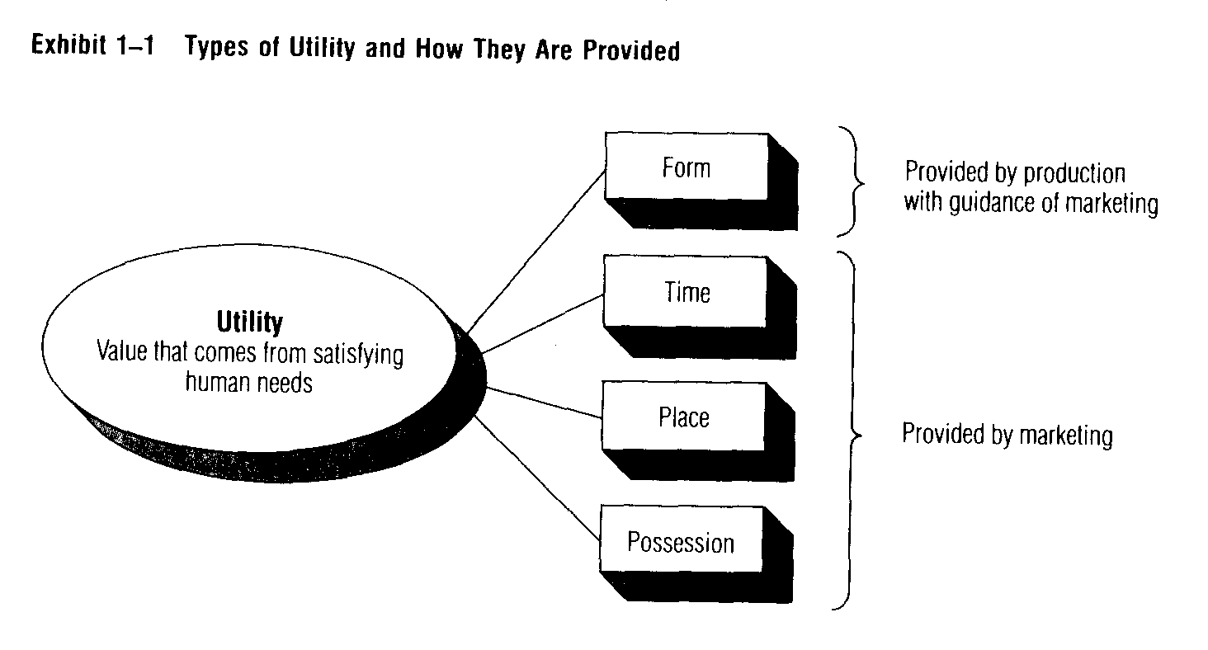

Even when marketing and production combine to provide form utility, consumers won't be satisfied until possession, time, and place utility are also provided.
Possession utility means obtaining a product and having the right to use or consume it. Customers usually exchange money or something else of value for possession utility.
Time utility means having the product available when the customer wants it.
And place utility means having the product available where the customer wants it. Tennis rackets that stay at a factory don't do anyone any good. Time and place utility are important for services, too. For example, neighbourhood emergency-care health clinics have recently become very popular. People just walk in as soon as they feel sick, not a day later when their doctor can schedule an appointment.
Stated simply, marketing provides time, place, and possession utility. It should also guide decisions about what goods and services should be produced to provide form utility. We'll look at how marketing does this later in this chapter. First, we want to discuss why you should study marketing, and then we'll define marketing.

MARKETING IS IMPORTANT TO YOU

Why you should study marketing

One reason for studying marketing is that you-as a consumer-pay for the cost of marketing activities. Marketing costs about 50 cents of your consumer dollar. For some goods and services, the percentage is much higher.
Another important reason for learning about marketing is that marketing affects almost every aspect of your daily life. All the goods and services you buy, the stores where you shop, and the radio and TV programs paid for by advertising are there because of marketing. Even your job résumé is part of a marketing campaign to sell yourself to some employer! Some courses are interesting when you take
them but never relevant again once they're over. Not so with marketing-you'll be a consumer dealing with marketing for the rest of your life.
Still another reason for studying marketing is that there are many exciting and rewarding career opportunities in marketing. Marketing is often the route to the top. Throughout this book you will find information about opportunities in different areas of marketing-in sales, advertising, product management, marketing research, physical distribution, and other areas. And, Appendix C is all about career planning in marketing.
Even if you're aiming for a non-marketing job, you'll be working with marketing people. Knowing something about marketing will help you understand them better. It will also help you do your own job better. Marketing is important to the success of every organization. Remember, a company that can't successfully sell its products doesn't need accountants, financial managers, production managers, personnel managers, computer programmers, or credit managers.
Even if you're not planning a business career, marketing concepts and techniques apply to non-profit organizations, too. Many non-profit organizations have a marketing manager. And the same basic principles used to sell soap are also used to "sell" ideas, politicians, mass transportation, health-care services, conservation, museums, and even colleges. Think about the school where you take this course. If you didn't know about its offerings-or if they didn't interest you-you would simply pick some other school.'
An even more basic reason for studying marketing is that marketing plays a big part in economic growth and development. Marketing stimulates research and new ideas-resulting in new goods and services. Marketing gives customers a choice among products. If these products satisfy customers, fuller employment, higher incomes, and a higher standard of living can result. An effective marketing system is important to the future of our nation-and all nations.

HOW SHOULD WE DEFINE MARKETING?

As we said earlier, some people define marketing too narrowly as "selling and advertising:' On the other hand, one authority defined marketing as "the creation and delivery of a standard of living:'3 That definition is too broad.
An important difference between the two definitions may be less obvious. The first definition is a micro-level definition. It focuses on activities performed by an individual organization. The second is a macro-level definition. It focuses on the economic welfare of a whole society.

Micro- or macro-marketing?

Which view is correct? Is marketing a set of activities done by individual firms or organizations? Or is it a social process?
To answer this question, let's go back to our tennis racket example. We saw that a producer of tennis rackets has to perform many customer-related activities besides just making rackets. The same is true for an insurance company, an art museum, or a family-service agency. This supports the idea of marketing as a set of activities done by individual organizations.
On the other hand, people can't live on tennis rackets and art museums alone! In an advanced economy like ours, it takes thousands of goods and services to satisfy the many needs of society. A typical K mart stocks 25,000 different items. A society needs some sort of marketing system to organize the efforts of all the producers and middlemen needed to satisfy the varied needs of all its citizens. So marketing is also an important social process.
The answer to our question is that marketing is both a set of activities performed by organizations and a social process. In other words, marketing exists at both the micro and macro levels. Therefore, we will use two definitions of marketing-one for micro-marketing and another for macro-marketing. The first looks at customers and the organizations that serve them. The second takes a broad view of our whole production-distribution system.

MICRO-MARKETING DEFINED

Micro-marketing is the performance of activities that seek to accomplish an organization's objectives by anticipating customer or client needs and directing a flow of need-satisfying goods and services from producer to customer or client. Let's look at this definition.°

Applies to profit and non-profit organizations

To begin with, this definition applies to both profit and non-profit organizations. Profit is the objective for most business firms. But other types of organizations may seek more members-or acceptance of an idea. Customers or clients may be individual consumers, business firms, non-profit organizations, government agencies, or even foreign nations. While most customers and clients pay for the goods and services they receive, others may receive them free of charge or at a reduced cost through private or government support.

More than just persuading customers

You already know that micro-marketing isn't just selling and advertising. Unfortunately, many executives still think it is. They feel that the job of marketing is to "get rid of" whatever the company happens to produce. In fact, the aim of marketing is to identify customers' needs-and meet those needs so well that the product (goods and/or services) almost "sells itself:' If the whole marketing job has been done well, the customer doesn't need much persuading. He should be ready to buy.

Begins with customer needs

Marketing should begin with potential customer needs-not with the production process. Marketing should try to anticipate needs. And then marketing, rather than production, should determine what goods and services are to be developed including decisions about product design and packaging; prices or fees; credit and collection policies; use of middlemen; transporting and storing policies; advertising and sales policies; and, after the sale, installation, warranty, and perhaps even disposal policies.

Marketing does not do it alone

This does not mean that marketing should try to take over production, accounting, and financial activities. Rather, it means that marketing-by interpreting customers' needs-should provide direction for these activities and try to coordinate them. After all, the purpose of a business or non-profit organization is to satisfy customer or client needs. It is not to supply goods and services that are convenient to produce and might sell or be accepted free.

THE FOCUS OF THIS TEXT-MANAGEMENT-ORIENTED MICRO-MARKETING

Since most of you are preparing for a career in business, the main focus of this text will be on micro-marketing. We will see marketing through the eyes of the marketing manager. But most of this material will also be useful for those who plan to work for non-profit organizations.
Marketing managers must remember that their organizations are just small parts of a larger macro-marketing system, however. Therefore, the rest of this chapter will look at the macro-view of marketing. Let's begin by defining macro-marketing and reviewing some basic ideas. Then, in Chapter 2, we'll explain the marketing management decision areas we will be discussing in the rest of the book.

.
.
.
.
.
.
.
.
.
.
.
.
.

MACRO-MARKETING DEFINED

Macro-marketing is a social process that directs an economy's flow of goods and services from producers to consumers in a way that effectively matches supply and demand and accomplishes the objectives of society.

Emphasis is on whole system

Like micro-marketing, macro-marketing is concerned with the flow of need-satisfying goods and services from producer to consumer. However, the emphasis with macro-marketing is not on the activities of individual organizations. Instead, the emphasis is on how the whole marketing system works. This includes looking at how marketing affects society and vice versa.
Every society needs a macro-marketing system to help match supply and demand. Different producers in a society have different objectives, resources, and skills. Likewise, not all consumers share the same needs, preferences, and wealth. In other words, within any society there are both heterogeneous supply capabilities and heterogeneous demands for goods and services. The role of a macro-marketing system is to effectively match this heterogeneous supply and demand and at the same time accomplish society's objectives.

Is it effective and fair?

The effectiveness and fairness of a particular macro-marketing system must be evaluated in terms of that society's objectives. Obviously, all nations don't share the same objectives. For example, Swedish citizens receive many "free" services-like health care and retirement benefits. Goods and services are fairly evenly distributed among the Swedish population. By contrast, until recently, Russia placed much less emphasis on producing goods and services for individual consumers-and more on military spending. In Venezuela, the distribution of goods and services is very uneven-with a big gap between the "have-nots" and the elite "haves:' Whether each of these systems is judged "fair" or "effective" depends on the objectives of the society.
Let's look more closely at macro-marketing. And to make this more meaningful to you, consider (1) what kind of a macro-marketing system we have and (2) how effective and fair it is.

EVERY SOCIETY NEEDS AN ECONOMIC SYSTEM

All societies must provide for the needs of their members. Therefore, every society needs some sort of economic system-the way an economy organizes to use scarce resources to produce goods and services and distribute them for consumption by various people and groups in the society.
How an economic system operates depends on a society's objectives and the nature of its political institutions. But, regardless of what form these take, all economic systems must develop some method-along with appropriate economic institutions-to decide what and how much is to be produced and distributed by whom, when, and to whom. How these decisions are made may vary from nation to nation. But the macro-level objectives are basically similar: to create goods and services and make them available when and where they are needed-to maintain or improve each nation's standard of living.

HOW ECONOMIC DECISIONS ARE MADE

There are two basic kinds of economic systems: planned systems and market-directed systems. Actually, no economy is entirely planned or market-directed. Most are a mixture of the two extremes.

Government planners may make die decisions

In a planned economic system government planners decide what and how much is to be produced and distributed by whom, when, and to whom. Producers generally have little choice about what goods and services to produce. Their main task is to meet their assigned production quotas. Prices are set by government planners and tend to be very rigid-not changing according to supply and demand. Consumers usually have some freedom of choice-it's impossible to control every single detail! But the assortment of goods and services may be quite limited. Activities such as market research, branding, and advertising usually are neglected. Sometimes they aren't done at all.
Government planning may work fairly well as long as an economy is simple and the variety of goods and services is small. It may even be necessary under certain conditions-during wartime, for example. However, as economies become more complex, government planning becomes more difficult. It may even break down. Planners may be overwhelmed by too many complex decisions. And consumers may lose patience if the planners don't respond to their needs. Labour strikes in Poland illustrate this. The Polish workers want the government to change the plan so that needed consumer products will be available. To try to reduce such consumer dissatisfaction, planners in the Soviet Union, China, and other socialist countries have put more emphasis on marketing (branding, advertising, and market research) in recent years.

A market-directed economy adjusts itself

In a market-directed economic system, the individual decisions of the many producers and consumers make the macro-level decisions for the whole economy. In a pure market-directed economy, consumers make a society's production decisions when they make their choices in the marketplace. They decide what is to be produced and by whom-through their dollar "votes.”

Price is a measure of value

Prices in the marketplace are a rough measure of how society values particular goods and services. If consumers are willing to pay the market prices, then apparently they feel they are getting at least their money s worth. Similarly, the cost of labour and materials is a rough measure of the value of the resources used in the production of goods and services to meet these needs. New consumer needs that can be served profitably-not just the needs of the majority-will probably be met by some profit-minded businesses.
In summary, in a market-directed economic system the prices in both the production sector (for resources) and the consumption sector (for goods and services) vary to allocate resources and distribute income according to consumer preferences. The result is a balance of supply and demand and the coordination of the economic activity of many individuals and institutions.

Greatest freedom of choice

Consumers in a market-directed economy enjoy maximum freedom of choice. They are not forced to buy any goods or services, except those that must be provided for the good of society-things such as national defense, schools, police and fire protection, highway systems, and public-health services. These are provided by the community-and the citizens are taxed to pay for them.
Similarly, producers are free to do whatever they wish-provided that they stay within the rules of the game set by government and receive enough dollar "votes" from consumers. If they do their job well, they earn a profit and stay in business. But profit, survival, and growth are not guaranteed.

Conflicts can result

Conflicts and difficulties can come from producers and consumers making free choices. This is called the micro-macro dilemma: what is "good" for some producers and consumers may not be good for society as a whole.
Gun control is an example. Each year thousands of people are killed with handguns. There are producers who make and sell handguns at a profit. And there are many consumers who feel strongly about their right to own guns. But others argue that handguns are a threat to society. They want handgun sales banned and sales of all weapons limited. Should gun producers be allowed to sell guns to consumers who want them?
Sometimes such decisions don't involve a matter of life and death but are still important. Many Americans want the convenience of soft drinks in cheap, disposable aluminium cans. But often these same cans end up sprinkled along the roads and must be picked up at taxpayer expense. Should only can buyers (through special charges)-or all of us-have to pay for this littering?

The role of government

The American economy is mainly market-directed-but not completely. Society assigns supervision of the system to the government. For example, besides setting and enforcing the "rules of the game;' the federal government controls interest rates and the supply of money. It also sets import and export rules that affect international competition, regulates radio and TV broadcasting, sometimes controls wages, and prices, and so on. Government also tries to be sure that property is protected, contracts are enforced, individuals are not exploited, no group unfairly monopolizes markets, and producers deliver the kinds and quality of goods and services they claim to be offering.
You can see that some of these government activities are needed to make sure the economy runs smoothly. However, some people worry that too much government "guidance" is a threat to the survival of our market-directed system-and the economic and political freedom that goes with it. In the past decade, there has been much less "interference" by federal government-especially in markets for services such as banking, transportation, and communications. The vigorous competition among airlines is a good example of what follows. A few years ago a government agency controlled airline prices and routes. Now that agency doesn't exist, and these decisions are made by marketing managers-and consumers.

ALL ECONOMIES NEED MACRO-MARKETING SYSTEMS

At this point, you may be saying to yourself: all this sounds like economics where does marketing fit in? Studying a macro-marketing system is a lot like studying an economic system except we give more detailed attention to the "marketing" components of the system-including consumers and other customers, middlemen, and marketing specialists. The focus is on the activities they perform and how the interaction of the components affects the effectiveness and fairness of a particular system.
In general, we can say that no economic system-whether centrally planned or market-directed-can achieve its objectives without an effective macro-marketing system. To see why this is true, we will look at the role of marketing in primitive economies. Then we will see how macro-marketing tends to become more and more complex in advanced economic systems.

Marketing involves exchange

In a pure subsistence economy, each family unit produces everything it consumes. There is no need to exchange goods and services. Each producer-consumer unit is totally self-sufficient. No marketing takes place because marketing doesn't occur unless two or more parties are willing to exchange something for something else.

What is a market?

The term marketing comes from the word market which is a group of sellers and buyers who are willing to exchange goods and/or services for something of value. Of course, some negotiation may be needed. This can be done face-to-face at some physical location (for example, a farmers' market). Or it can be done indirectly-through a complex network of middlemen who link buyers and sellers who are far apart.
In primitive economies, exchanges tend to occur in central markets. Central markets are convenient places where buyers and sellers can meet face-to-face to exchange goods and services. We can understand macro-marketing better by seeing how and why central markets develop.

Central markets help exchange

Imagine a small village of five families-each with a special skill for producing some need-satisfying product. After meeting basic needs, each family decides to specialize. It's easier for one family to make two pots and another to make two baskets than for each one to make one pot and one basket. Specialization makes labour more efficient and more productive. It can increase the total amount of form utility created.
If these five families each specialize in one product, they will have to trade with each other. As Exhibit 1-2A shows, it will take the five families 10 separate exchanges to obtain some of each of the products. If the families live near each other, the exchange process is relatively simple. But if they are far apart, travel back and forth will take time. Who will do the travelling-and when?
Faced with this problem, the families may agree to come to a central market and trade on a certain day. Then each family makes only one trip to the market to trade with all the others. This reduces the total number of trips to five, which makes exchange easier, leaves more time for producing and consuming, and also provides for social gatherings. In total, much more time, place, possession, and even form utility is enjoyed by each of the five families.

Money system speeds trading

While a central meeting place simplifies exchange, the individual bartering transactions still take a lot of time. Bartering only works when someone else wants what you have, and vice versa. Each trader must find others who have products of about equal value. After trading with one group, a family may find itself with extra baskets, knives, and pots. Then it has to find others willing to trade for these products. A money system changes all this. A seller only has to find a buyer who wants his products and agrees on the price. Then the seller is free to spend this income to buy whatever he wants.

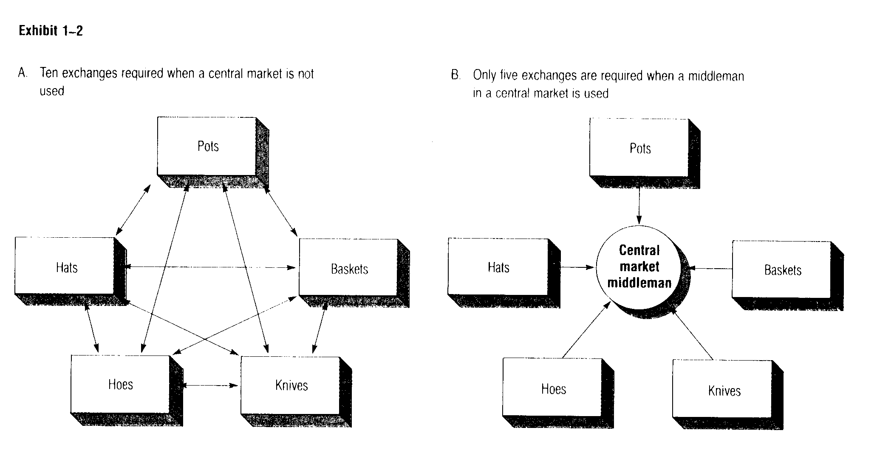

Middlemen help exchange even more

The development of a central market and a money system simplifies the exchange process among the five families in our imaginary village. But a total of 10 separate transactions is still required. Thus, it still takes a lot of time and effort to carry out exchange among the
five families.
This clumsy exchange process is made much simpler by the appearance of a middleman-someone who specializes in trade rather than production. A middleman is willing to buy each family's goods and then sell each family whatever it needs. He charges for his services, of course. But this charge may be more than offset by savings in time and effort.
In our simple example, using a middleman at a central market reduces the necessary number of exchanges for all five families from 10 to 5. See Exhibit 1-2B. Each family has more time for production, consumption, and leisure. Also, each family can specialize in production-creating more form utility. Meanwhile, by specializing in trade, the middleman provides additional time, place, and possession utility. In total, all the villagers may enjoy greater economic utility-and greater consumer satisfaction-by using a middleman in the central market.
Note that the reduction in transactions that results from using a middleman in a central market becomes more important as the number of families increases. For example, if the population of our imaginary village increases from 5 to 10 families, 45 transactions are needed without a middleman. Using a middleman requires only one transaction for each family.
Today such middlemen-offering permanent trading facilities-are known as wholesalers and retailers. The advantages of working with middlemen increase as the number of producers and consumers, their distance from each other, and the number and variety of competing products increase. That is why there are so many wholesalers and retailers in modern economies.

THE ROLE OF MARKETING IN ECONOMIC DEVELOPMENT

Modern economies have advanced well beyond the five-family village, but the same ideas still apply. The main purpose of markets and middlemen is to make exchange easier and allow greater time for production, consumption, and other activities-including recreation.

Effective marketing system is necessary

Although it is tempting to conclude that more effective macro-marketing systems are the result of greater economic development, just the opposite is true. An effective macro-marketing system is necessary for economic development. Improved marketing may be the key to growth in less-developed nations.

Breaking the vicious circle of poverty

Without an effective macro-marketing system, the less-developed nations may not be able to escape the "vicious circle of poverty." Many people in these nations can't leave their subsistence way of life to produce for the market because there are no buyers for what they produce. And there are no buyers because everyone else is producing for their own needs. As a result, distribution systems and middlemen do not develop.
Breaking this vicious circle of poverty may require major changes in the inefficient micro- and macro-marketing systems that are typical in less-developed nations. At the least, more market-oriented middlemen are needed to move surplus output to markets where there is more demand. Peace Corps workers often help organize local production-distribution efforts-to show the possibilities. For example, local fresh vegetables have been assembled by producers cooperatives in East Africa and shipped to nearby cities where prices were much “ higher.”

Pepsi Barters with Cashless Buyers

Every country has a money system. However, government planners in developing nations often won't let local customers spend cash on foreign-made products. They want the money-and the opportunities for jobs and economic growth-to stay in the local economy. To
facilitate exchange in these markets, American firms have turned to counter trade a special type of bartering. The U.S. company takes its payment in products, not money. For example, soft-drink bottlers in Mexico trade locally grown finds a market for the broccoli in the United States. Consumers in Nicaragua sip Pepsi because the company takes sesame seeds and molasses in trade. Distribution systems and middlemen have not yet developed in these countries to handle this sort of exchange. In pursuing its own opportunities, Pepsi is also stimulating economic development. Pepsi is not alone in using counter-trade. About 6 percent of all U.S. exports rely on counter-trade.

CAN MASS PRODUCTION SATISFY A SOCIETY'S CONSUMPTION NEEDS?

Urbanization brings together large numbers of people. They must depend on others to produce most of the goods and services they need to satisfy their basic needs. Also, in advanced economies, many consumers have higher discretionary incomes. They can afford to satisfy higher-level needs as well. A modern economy faces a real challenge to satisfy all these needs.

Economies of scale mean lower cost

Fortunately, advanced economies can often take advantage of mass production with its economies of scale-which means that as a company produces larger numbers of a particular product, the cost for each of these products goes down. You can see that a one-of-a-kind, custom-built car would cost much more than a mass-produced standard model.
Of course, even in our advanced society, not all goods and services can be produced by mass production-or with economies of scale. Consider medical care.
It's difficult to get productivity gains in labour-intensive medical services-like brain surgery. Nevertheless, from a macro-marketing perspective, it is clear that we are able to devote resources to meeting these "quality of life" needs because we are achieving efficiency in other areas.
Thus, modern production skills can help provide great quantities of goods and services to satisfy large numbers of consumers. But mass production alone does not solve the problem of satisfying consumers' needs. Effective marketing is also needed.

Effective marketing is needed to link producers and consumers

Effective marketing means delivering the goods and services that consumers want and need. It means getting products to them at the right time, in the right place, and at a price they're willing to pay. That's not an easy job-especially if you think about the variety of goods and services a highly developed economy can produce-and the many kinds of goods and services consumers want.
Effective marketing in an advanced economy is more difficult because producers and consumers are separated in several ways. As Exhibit 1-3 shows, exchange between producers and consumers is hampered by spatial separation, separation in time, separation in information and values, and separation of ownership. Exchange is further complicated by "discrepancies of quantity” and "discrepancies of assortment" between producers and consumers. That is, each producer specializes in producing and selling large amounts of a narrow assortment of goods and services, but each consumer wants only small quantities of a wide assortment of goods and services."

Marketing functions help narrow the gap

The universal functions of marketing are: buying, selling, transporting, storing, standardization and grading, financing, risk taking, and market information. They must be performed in all macro-marketing systems. How these functions are performed-and by whom-may differ among nations and economic systems. But they are needed in any macro-marketing system. Let's take a closer look at them now.
Exchange usually involves buying and selling. The buying function means looking for and evaluating goods and services. The selling function involves promoting the product. It includes the use of personal selling, advertising, and other mass selling methods. This is probably the most visible function of marketing.
The transporting function means the movement of goods from one place to another. The storing function involves holding goods until customers need them.
Standardization and grading involve sorting products according to size and quality. This makes buying and selling easier because it reduces the need for inspection and sampling. Financing provides the necessary cash and credit to produce, transport, store, promote, sell, and buy products. Risk taking involves bearing the uncertainties that are part of the marketing process. A firm can never be sure that customers will want to buy its products. Products can also be damaged, stolen, or outdated. The market information function involves the collection, analysis, and distribution of all the information needed to plan, carry out, and control marketing activities.

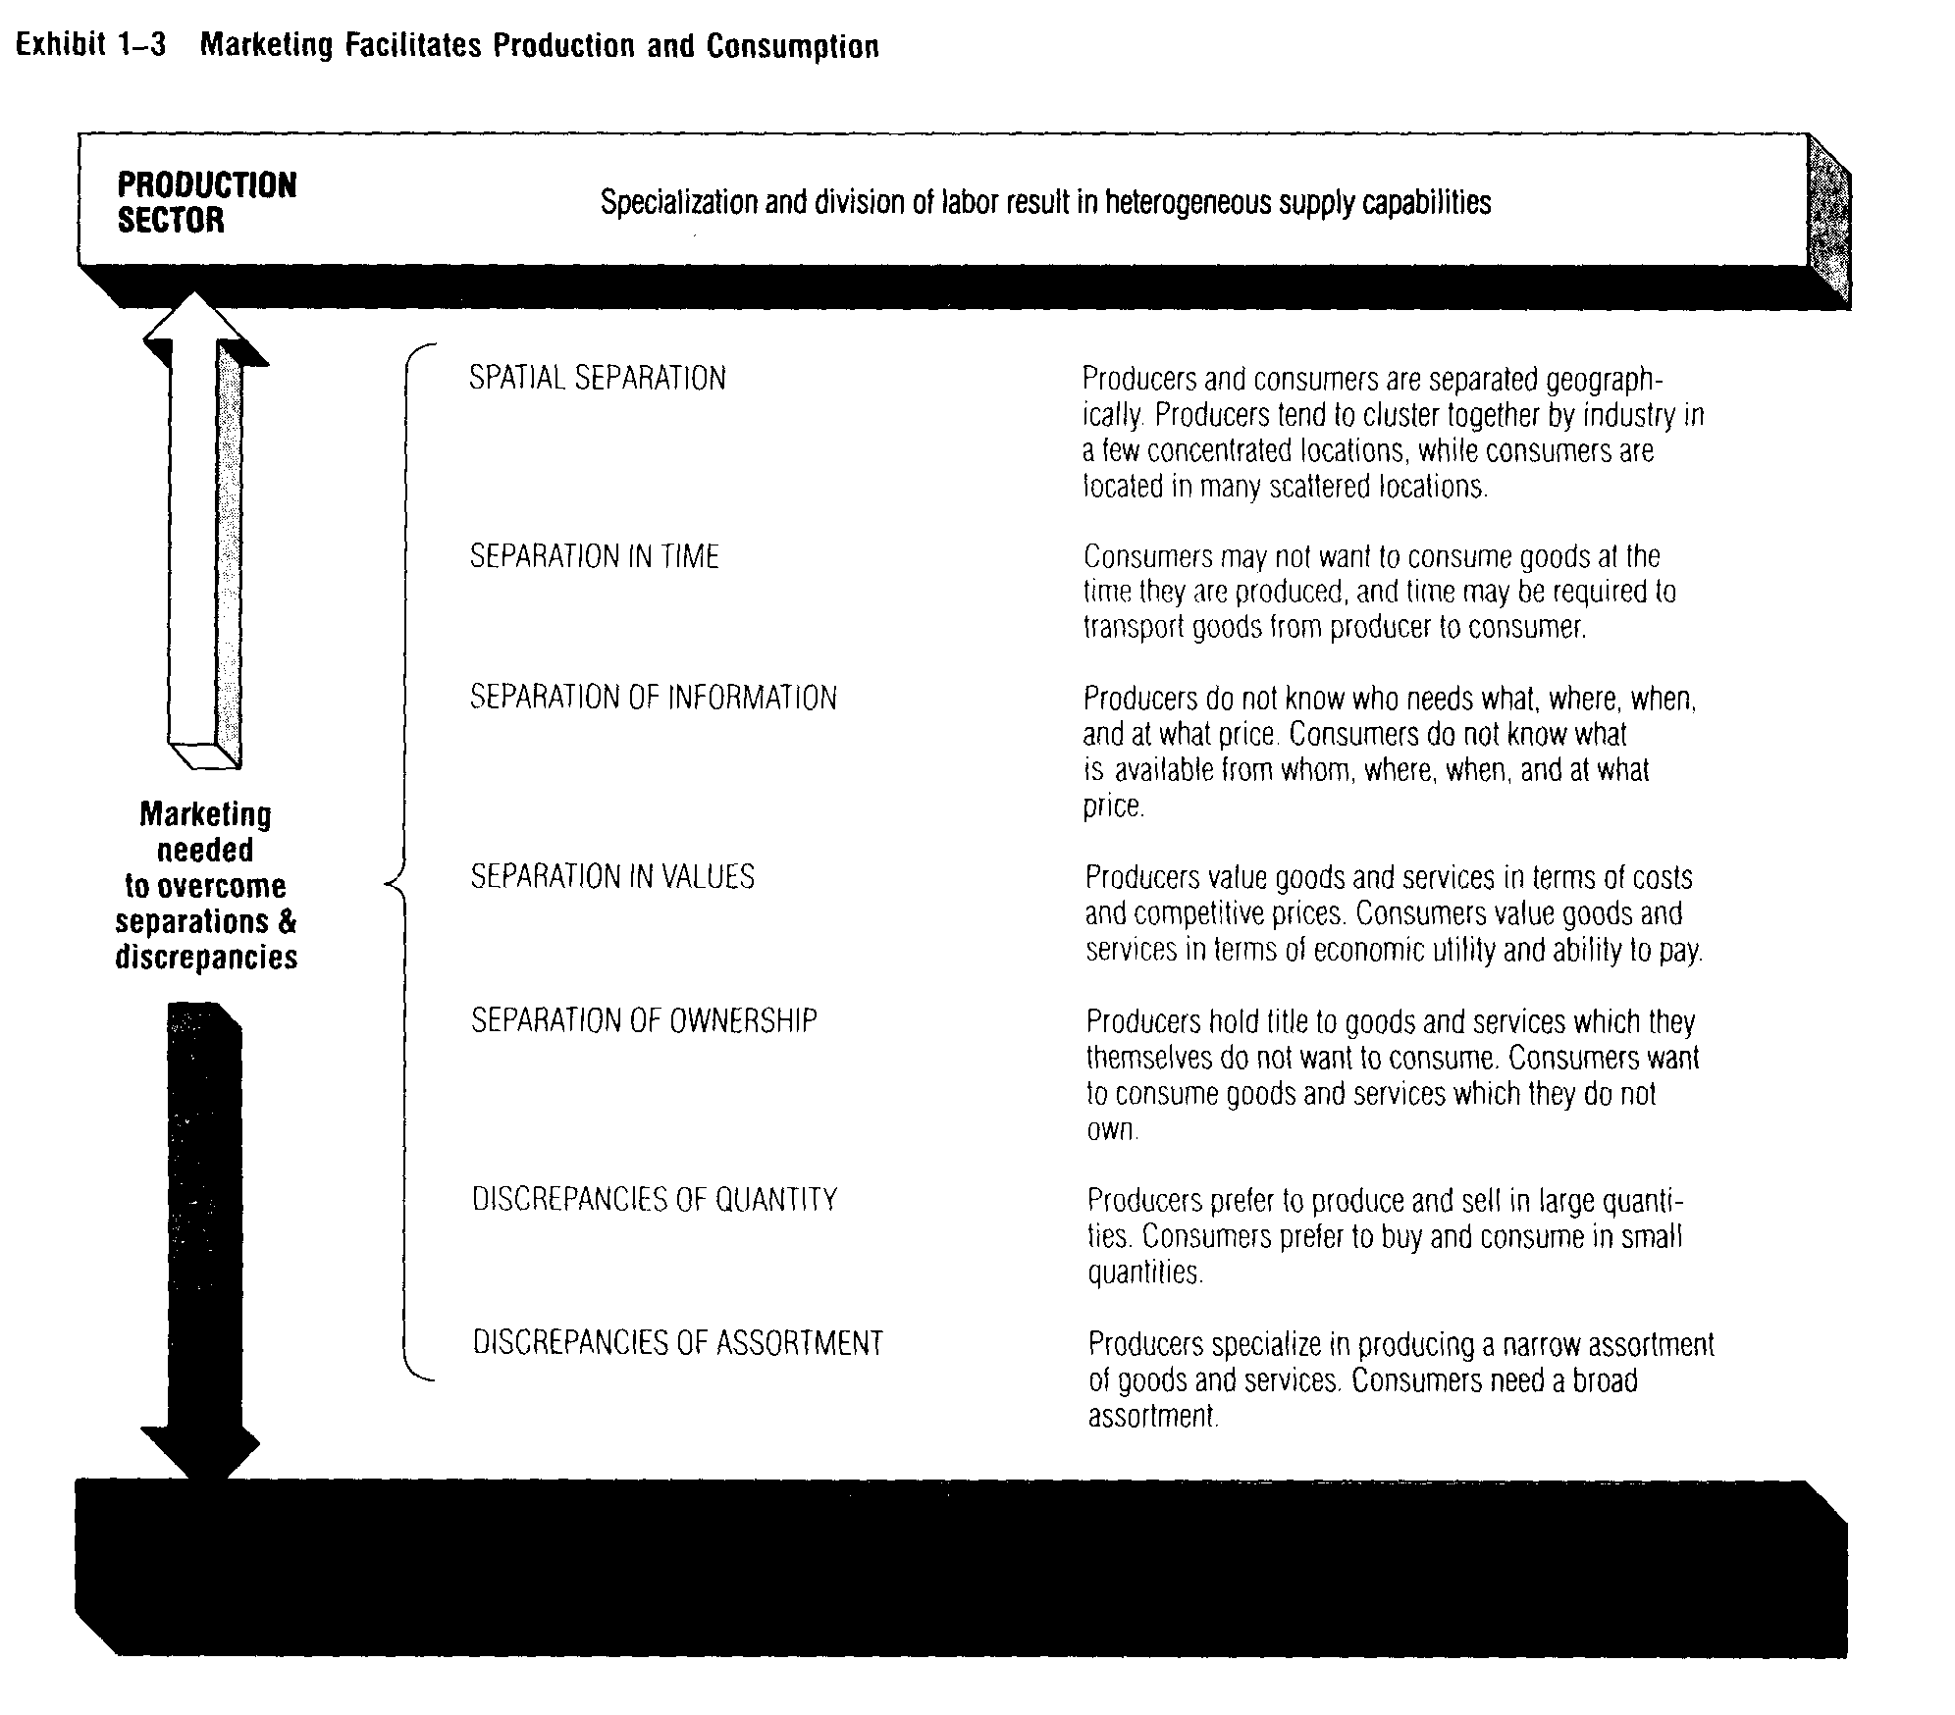

CONSUMPTION

SECTOR

Heterogeneous demand for form, time, place, and possession utility to satisfy needs and wants

WHO PERFORMS MARKETING FUNCTIONS?

Producers, consumers, and marketing specialists

From a macro-level viewpoint, these marketing functions are all part of the marketing process-and must be done by someone. None of them can be eliminated. In a planned economy, some of the functions may be performed by government agencies. Others may be left to individual producers and consumers. In a market-directed economy, marketing functions are performed by producers, consumers, and a variety of marketing specialists. See Exhibit 1-4.

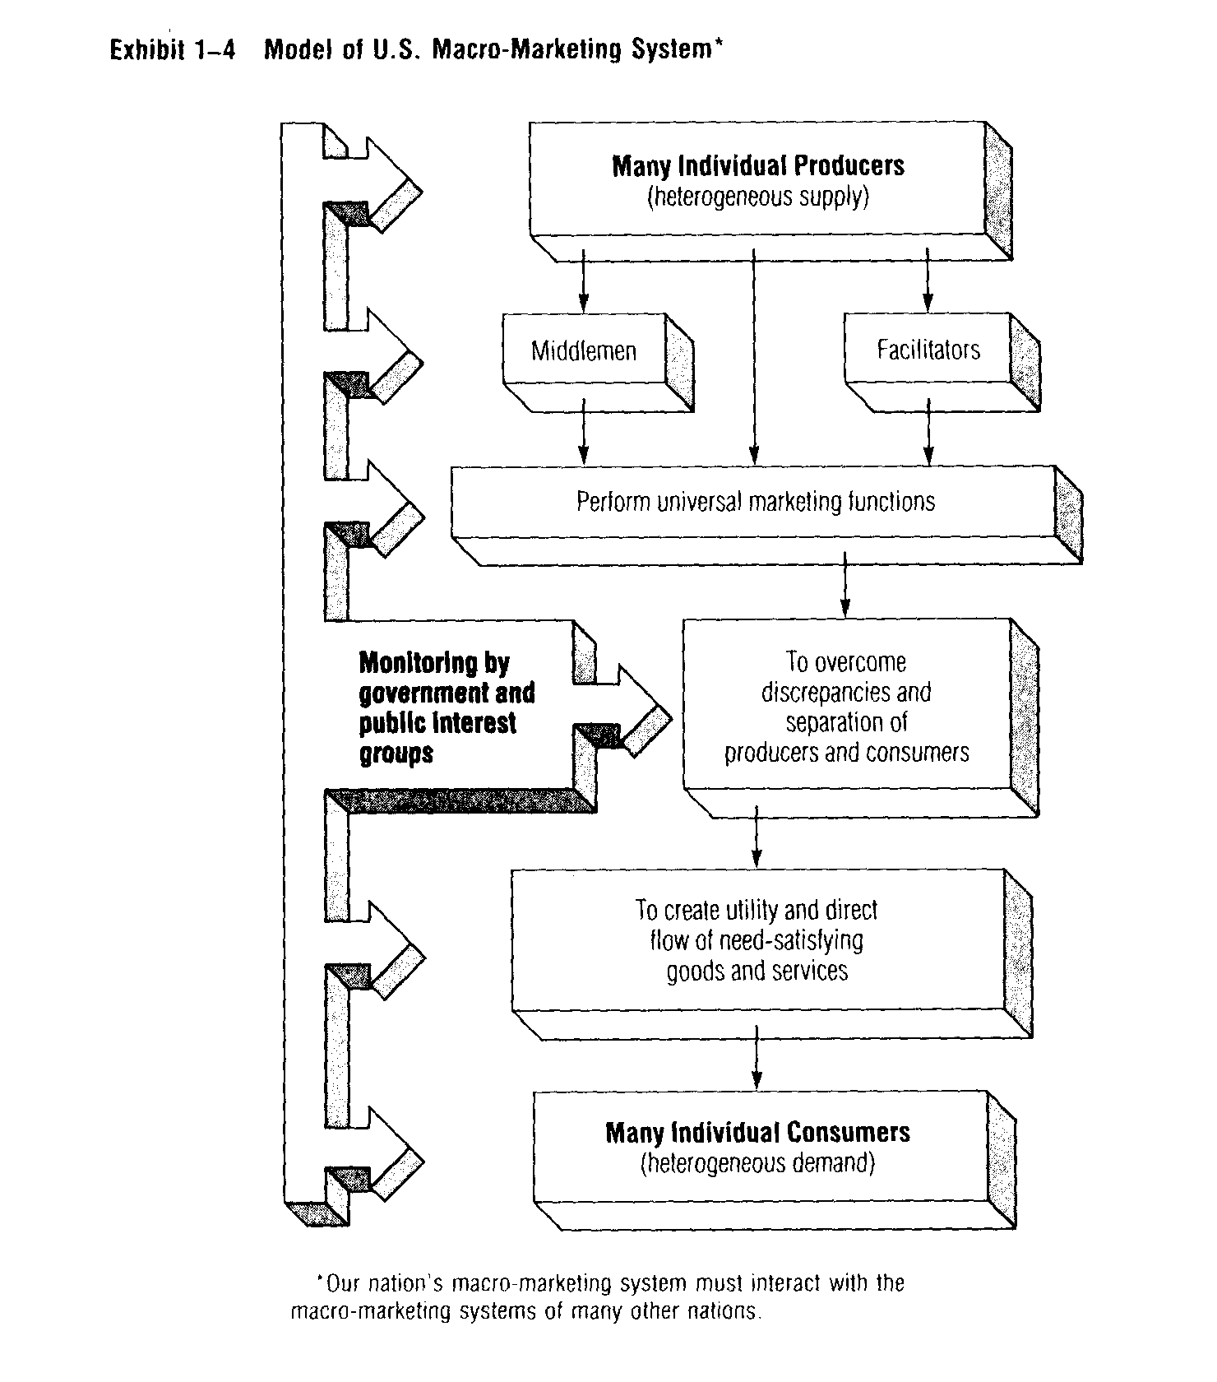

Specialists perform some functions

Earlier in this chapter, you saw how producers and consumers benefited when marketing specialists (middlemen) took over some buying and selling. Producers and consumers also benefit when marketing specialists perform the other marketing functions. So we find marketing functions being performed not only by marketing middlemen but also by a variety of other facilitators-firms that provide one or more of the marketing functions other than buying or selling. These include advertising agencies, marketing research firms, independent product-testing laboratories, public warehouses, transporting firms, and financial institutions (including banks). ,. Through specialization or economies of scale, marketing middlemen end facilitators are often able to perform the marketing functions better-and at a lower cost - than producers or consumers can. This allows producers and consumers to spend more time on production and consumption.

Functions can be shifted and shared

From a macro viewpoint, all of the marketing functions must be performed by ~ someone. But, from a micro viewpoint, not every firm must perform all of the functions. Further, not all goods and services require all the functions at every level of their production. "Pure services"-like a plane ride-don't need storing, for example. But storing is required in the production of the plane and while the plane is not in service.
Some marketing specialists perform all the functions. Others specialize in only one or two. Marketing research firms, for example, specialize only in the market information function. The important point to remember is this: responsibility for performing the marketing functions can be shifted and shared in a variety of ways, but no function can be completely eliminated.

HOW WELL DOES OUR MACKO-MARKETING SYSTEM WORK?

It connects remote producers and consumers

A macro-marketing system does more than just deliver goods and services to consumers-it allows mass production with its economies of scale. Also, mass communication and mass transportation allow products to be shipped where they're needed. Oranges from California are found in Minnesota stores-even in December-and electronic parts made in New York State are used in making products all over the country.'

It encourages growth and new ideas

In addition to making mass production possible, our market-directed, macro-marketing system encourages innovation-the development and spread of new ideas and products. Competition for consumers' dollars forces firms to think of new and better ways of satisfying consumer needs.

It has its critics

In explaining marketing's role in society, we described some of the benefits of our macro-marketing system. This approach is reasonable because our macro-marketing system has provided us-at least in material terms-with one of the highest standards of living in the world. It seems to be "effective" and "fair" in many ways.
We must admit, however, that marketing-as we know it in the United States has many critics! Marketing activity is especially open to criticism because it is the part of business most visible to the public. There is nothing like a pocketbook issue for getting consumers excited!
Typical complaints about marketing include:
Advertising is too often annoying, misleading, and wasteful. Products are not safe-or the quality is poor.
Marketing makes people too materialistic-it motivates them toward "things" instead of social needs.
Easy consumer credit makes people buy things they don't need and really can't afford.
Packaging and labeling are often confusing and deceptive.
Middlemen add to the cost of distribution-and raise prices without providing anything in return.
Marketing creates interest in products that pollute the environment. Too many unnecessary products are offered.
Marketing serves the rich and exploits the poor.

Note that some of these complaints deal with the whole macro-marketing system. Others apply to practices of specific firms and are micro-marketing oriented.

Consumer complaints should be taken seriously

Such complaints cannot and should not be taken lightly.'3 They show that many Americans aren't happy with some parts of our marketing system. Certainly, the strong public support for consumer protection laws proves that not all consumers feel they are being treated like kings and queens. But some of the complaints occur because people don't understand what marketing is. As you go through this book, we'll discuss some of these criticisms - to help you understand marketing better. Then, we will return to a more complete appraisal of marketing in our final chapter.

Chapter 2B
Economics Fundamentals
- The "law of diminishing demand:'
- What a market is.
- Demand and supply curves-and how they set the size of a market and its price level.
- Elasticity of demand and supply.
- Why demand elasticity can be affected by availability of substitutes.
- The important new terms (shown in red).

Questions and Problems

- Explain in your own words how economists look at markets and arrive at the "law of diminishing demand:'
- Explain what a demand curve is and why it is usually down-sloping.
- What is the length of life of the typical demand curve? Illustrate your answer.
- If the general market demand for men's shoes is fairly elastic, how does the demand for men's dress shoes compare to it? How does the demand curve for women's shoes compare to the demand curve for men's shoes?
- If the demand for razor blades is inelastic above and below the present price, should the price be raised? Why or why not?
- If the demand for steak is highly elastic below the present price, should the price be lowered?
- Discuss what factors lead to inelastic demand and supply curves. Are they likely to be found together in the same situation?
- Why would a marketing manager prefer to sell a product that has no close substitutes? Are "high profits" almost guaranteed?

A good marketing manager should be an expert on markets-and the nature of competition in markets. The economist’s traditional demand and supply analysis are useful tools for analysing markets. In particular, you should master the concepts of a demand curve and demand elasticity. A firm's demand curve shows how the target customers view the firm's Product-really its whole marketing mix. And the interaction of demand and supply curves helps set the size of a market-and the market price. These ideas are discussed more fully in the following sections.

PRODUCTS AND MARKETS AS SEEN BY CUSTOMERS AND POTENTIAL CUSTOMERS
Economists provide useful insights
How potential customers (not the firm) see a firm's product (marketing mix) affects how much they are willing to pay for it, where it should be made available, and how eager they are for it-if they want it at all. In other words, their view has a very direct bearing on marketing strategy planning.
Economists have been concerned with market behaviour for years. Their analytical tools can be quite helpful in summarizing how customers view products and how markets behave.

Economists see individual customers choosing among alternatives

Economics is sometimes called the "dismal" science-because it says that most customers have a limited income and simply cannot buy everything they want. They must balance their needs and the prices of various products.
But what exactly is the nature of a customer's desire for a particular product? Usually economists answer this question in terms of the extra utility the customer can obtain by buying more of a particular product-or how much utility would be lost if the customer had less of the product. (Students who wish further discussion of this approach should refer to indifference curve analysis in any standard economics text.)
It is easier to understand the idea of utility if we look at what happens when the price of one of the customer's usual purchases changes.

The law of diminishing demand

Suppose that a consumer buys potatoes in 10-pound bags at the same time he buys other foods such as bread and ~ice. If the consumer is mainly interested in buying a certain amount of food and the price of the potatoes drops, it seems reasonable to expect that he will switch some of his food money to potatoes and away from some other foods. But if the price of potatoes rises, you expect our consumer to buy fewer potatoes and more of other foods.
The general relationship between price and quantity demanded illustrated by this food example is called the law of diminishing demand-which says that if the price of a product is raised, a smaller quantity will be demanded and if the price of a product is lowered, a greater quantity will be demanded.

A group of customers makes a market

When our hypothetical consumers are considered as a group, we have a "market:' It is reasonable to assume that many consumers in a market will behave in a similar way. That is, if price declines, the total quantity demanded will increase and if price rises, the quantity demanded will decrease. Experience supports this reasoning, especially for broad product categories or commodities such as potatoes.
The relationship between price and quantity demanded in a market is what economists call a "demand schedule:' An example is shown in Exhibit A-1. The third column shows that the total revenue (sales) in the potato market-at possible prices-is equal to the quantity demanded times the price at those possible prices. Note that as prices go lower, the total unit quantity increases, yet the total revenue decreases. Fill in the blank lines in the third column and observe the behaviour of total
revenue-an important number for the marketing manager. We will explain what you should have noticed-and why-a little later.

The demand curve- usually down-sloping

If your only interest is seeing at which price customers will be willing to pay the greatest total revenue, the demand schedule may be adequate. But a demand curve "shows" more. A demand curve is a graph of the relationship between price

Exhibit A-1 Demand Schedule for Potatoes (10-pound bags)

Price of
potatoes (quality demanded Total revenue
per bag (bags per month) per month
Point (P) (Q) (P x (I = TR)
A $1.60 8,000,000 $12,800,000
B 1.30 9,000,000
C 1.00 11,000,000 11,000,000
D 0.70 14,000,000
E 0.40 19,000,000

and quantity demanded in a market-assuming that all other things stay the same. Exhibit A-2 shows the demand curve for potatoes-really just a plotting of the demand schedule. Demand curves show the price on the vertical axis and the quantity demanded on the horizontal axis. It shows how many potatoes potential customers will demand at various possible prices. This is a "down-sloping demand curve:'
Most demand curves are down-sloping. This just means that if prices are decreased, the quantity customers demand will increase.
Note that the demand curve only shows how customers will react to various prices. In a market, we see only one price at a time-not all of these prices. The curve, however, shows what quantities will be demanded-depending on what price is set.
You probably think that most businesspeople would like to set a price that would result in a large sales revenue. Before discussing this, however, we should consider the demand schedule and curve for another product to get a more complete picture of demand-curve analysis.

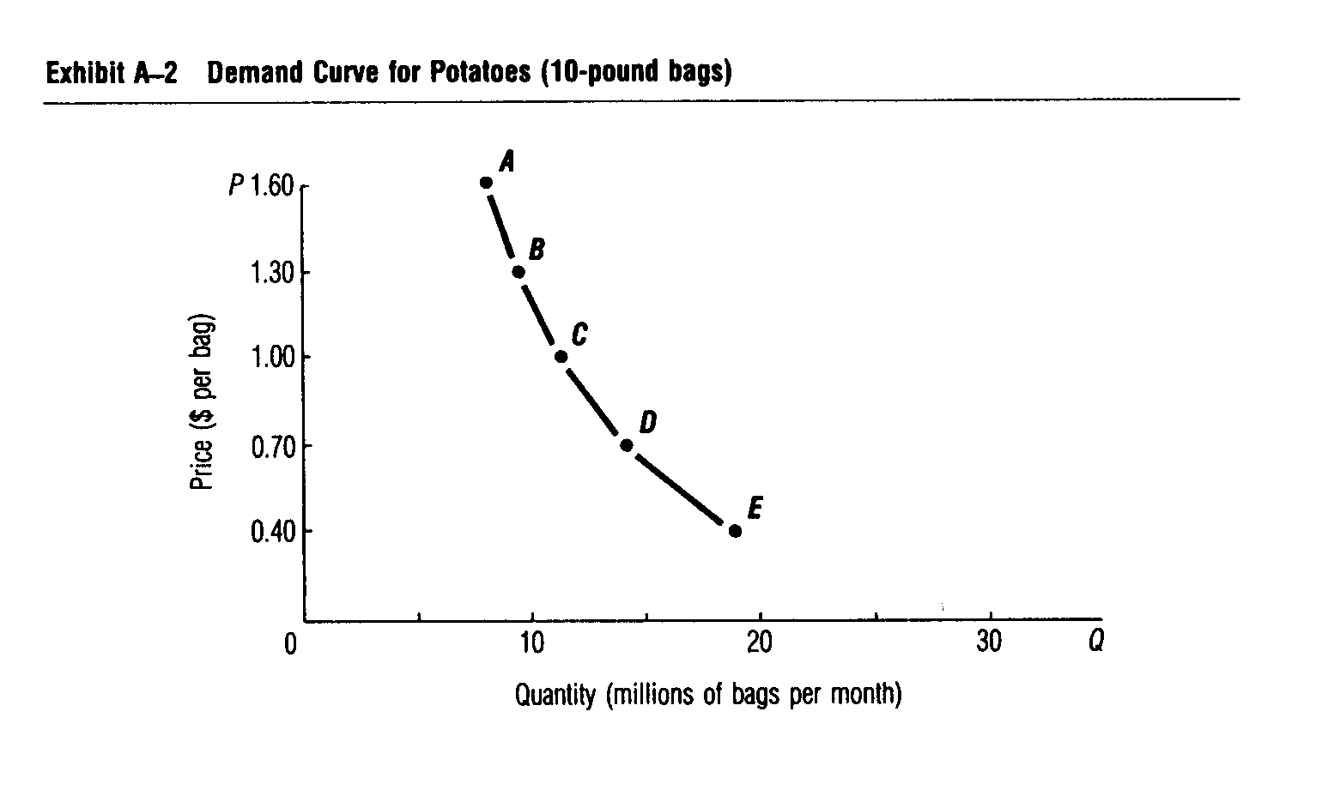

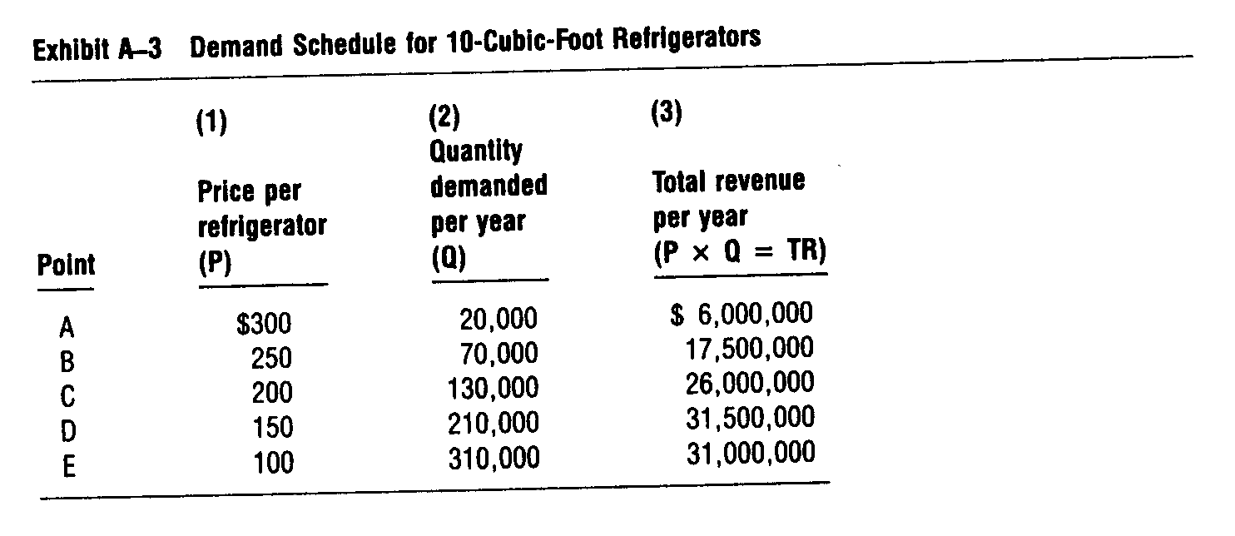

Refrigerator demand curve looks different

A different demand schedule is the one for standard 10-cubic-foot refrigerators shown in Exhibit A-3. Column (3) shows the total revenue that will be obtained at various possible prices and quantities. Again, as the price goes down, the quantity demanded goes up. But here, unlike the potato example, total revenue increases as prices go down-at least until the price drops to $150.

Every market has a demand curve-for some time period
These general demand-relationships are typical for all products. But each product has its own demand schedule and curve in each potential market-no matter how small the market. In other words, a particular demand curve has meaning only for a particular market. We can think of demand curves for individuals, groups of individuals who form a target market, regions, and even countries. And the time period covered really should be specified-although this is often neglected because we usually think of monthly or yearly periods.

The difference between elastic and inelastic

The demand curve for refrigerators (see Exhibit A-4) is down-sloping - but note that it is flatter than the curve for potatoes. It is important that we understand what this flatness means.

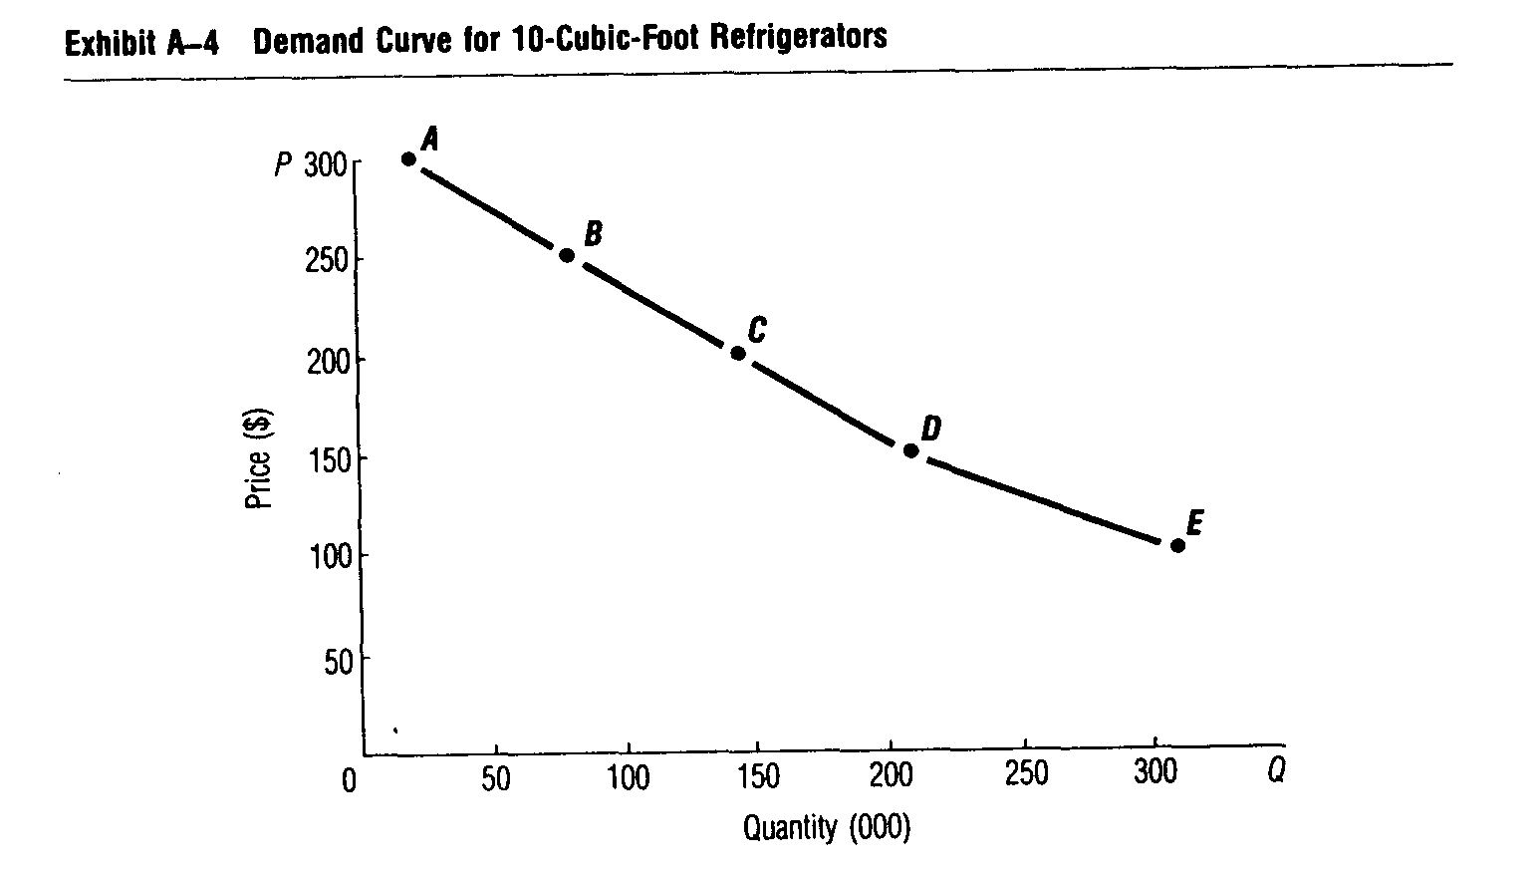

We will consider the flatness in terms of total revenue-since this is what interests business managers.'
When you filled in the total revenue column for potatoes, you should have noticed that total revenue drops continually if the price is reduced. This looks undesirable for sellers-and illustrates inelastic demand. Inelastic demand means that although the quantity demanded increases if the price is decreased, the quantity demanded will not "stretch" enough-that is, it is not elastic enough-to avoid a decrease in total revenue.
In contrast, elastic demand means that if prices are dropped, the quantity demanded will stretch (increase) enough to increase total revenue. The upper part of the refrigerator demand curve is an example of elastic demand.
But note that if the refrigerator price is dropped from $150 to $100, total revenue will decrease. We can say, therefore, that between $150 and $100, demand is inelastic - that is, total revenue will decrease if price is lowered from $150 to $100.
Thus, elasticity can be defined in terms of changes in total revenue. If total revenue will increase if price is lowered, then demand is elastic. If total revenue will decrease if price is lowered, then demand is inelastic.
(Note: A special case known as "unitary elasticity of demand" occurs if total revenue stays the same when prices change.)

.
.
.
.

Total revenue may increase if price is raised

A point that is often missed in discussions of demand is what happens when prices are raised instead of lowered. With elastic demand, total revenue will decrease if the price is raised. With inelastic demand, however, total revenue will increase if the price is raised.
The possibility of raising price and increasing dollar sales (total revenue) at the same time is attractive to managers. This only occurs if the demand curve is inelastic. Here, total revenue will increase if price is raised, but total costs probably will not increase-and may actually go down-with smaller quantities. Keep in mind that profit is equal to total revenue minus total costs. So-when demand is inelastic-profit will increase as price is increased!
The ways total revenue changes as prices are raised are shown in Exhibit A-5. Here, total revenue is the rectangular area formed by a price and its related quantity. The larger the rectangular area, the greater the total revenue.
P1 is the original price here, and the total potential revenue with this original price is shown by the area with blue shading. The area with red shading shows the total revenue with the new price, P2. There is some overlap in the total revenue areas, so the important areas are those with only one colour. Note that in the left-hand figure - where demand is elastic-the revenue added (the red-only area) when the price is increased is less than the revenue lost (the blue-only area). Now, Iet’s contrast this to the right-hand figure, when demand is inelastic. Only a small blue revenue area is given up for a much larger (red) one when price is raised.

An entire curve is not elastic or inelastic

It is important to see that it is wrong to refer to a whole demand curve as elastic or inelastic. Rather, elasticity for a particular demand curve refers to the change in total revenue between two points on the curve--not along the whole curve. You saw the change from elastic to inelastic in the refrigerator example. Generally, however, nearby points are either elastic or inelastic-so it is common to refer to a whole curve by the degree of elasticity in the price range that normally is of interest-the relevant range.

______________________________
' Strictly speaking, two curves should not be compared for flatness if the graph scales are different, but for our purposes now, we will do so to illustrate the idea of "elasticity of demand." Actually, it would be more correct to compare two curves for one product-on the same graph. Then both the shape of the demand curve and its position on the graph would be important.

Exhibit A-5 Changes in Total Revenue as Prices Increase

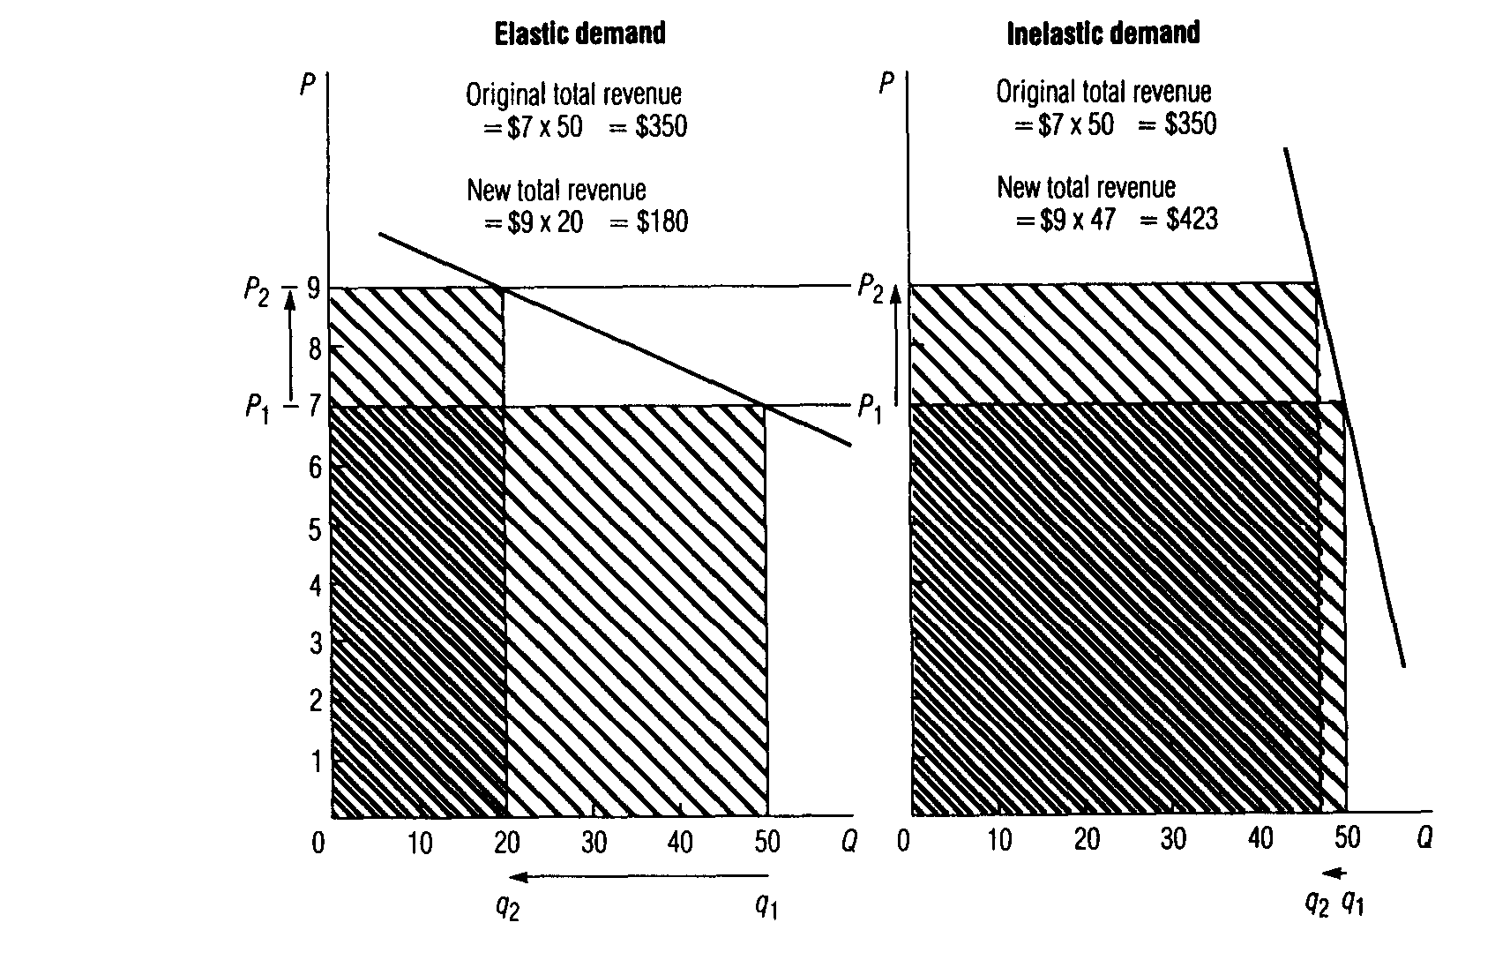

Demand elasticises affected by availability of substitutes and urgency of need

At first, it may be difficult to see why one product has an elastic demand and another an inelastic demand. Many factors affect elasticity-such as the availability of substitutes, the importance of the item in the customer's budget, and the urgency of the customer’s need and its relation to other needs. By looking more closely at one of these factors-the availability of substitutes-you will better understand why demand elasticises vary.
Substitutes are products that offer the buyer a choice. For example, many consumers see grapefruit as a substitute for oranges and hot dogs as a substitute for hamburgers. The greater the number of "good" substitutes available, the greater will be the elasticity of demand. From the consumer’s perspective, products are "good" substitutes if they are very similar (homogeneous). If consumers see products as extremely different-or heterogeneous-then a particular need cannot easily be satisfied by substitutes. And the demand for the most satisfactory product may be quite inelastic.
As an example, if the price of hamburger is lowered (and other prices stay the same), the quantity demanded will increase a lot-as will total revenue. The reason is that not only will regular hamburger users buy more hamburger, but some consumers who formerly bought hot dogs or steaks probably will buy hamburger, too. But if the price of hamburger is raised, the quantity demanded will decrease-perhaps sharply. Still, consumers will buy some hamburger-depending on how much the price has risen, their individual tastes, and what their guests expect (see Exhibit A-6).
In contrast to a product with many "substitutes"-such as hamburger--consider a product with few or no substitutes. Its demand curve will tend to be inelastic. Salt is a good example. Salt is needed to flavour food. Yet no one person or family uses great quantities of salt. So it is not likely that the quantity of salt purchased will change much as long as price changes are within a reasonable range.
Of course, if the price is dropped to an extremely low level, manufacturers may buy more-say, for low-cost filler instead of clay or sand (Exhibit A-7). O~, if the price is raised to a staggering figure, many people will have to do without. But these extremes are outside the relevant range.

Exhibit A-6 Demand Curve for Hamburger (a product with many substitutes)
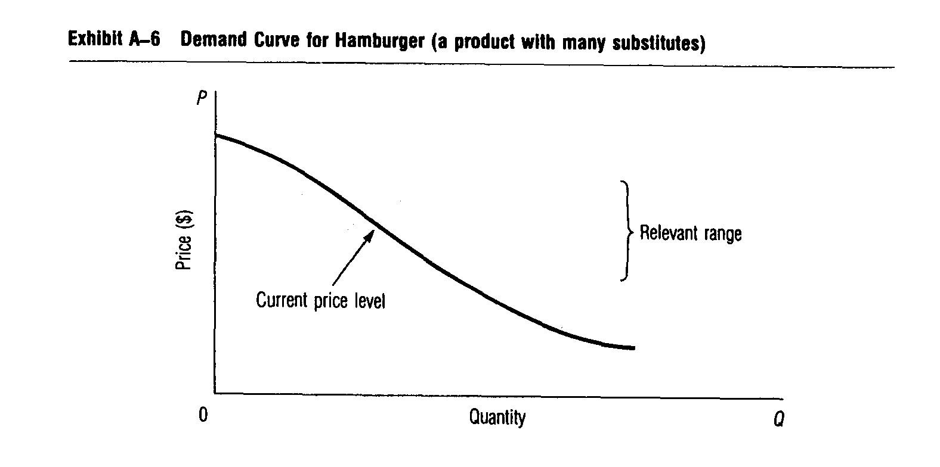
Demand curves are introduced here because the degree of elasticity of demand shows how potential customers feel about a product-and especially whether they see substitutes for the product. But to get a better understanding of markets, we must extend this economic analysis.

MARKETS AS SEEN BY SUPPLIERS

Customers may want some product-but if suppliers are not wilting to supply it, then there is no market. So we'll study the economist’s analysis of supply. And then we'll bring supply and demand together for a more complete understanding of markets.
Economists often use the kind of analysis we are discussing here to explain pricing in the marketplace. This is not our intention. Here we are interested in how and why markets work-and the interaction of customers and potential suppliers. The discussion in this appendix does not explain how individual firms set prices or should set prices. That will come in Chapters 18 and 19.

Exhibit A-7 Demand Curve for Salt (a product with few substitutes)
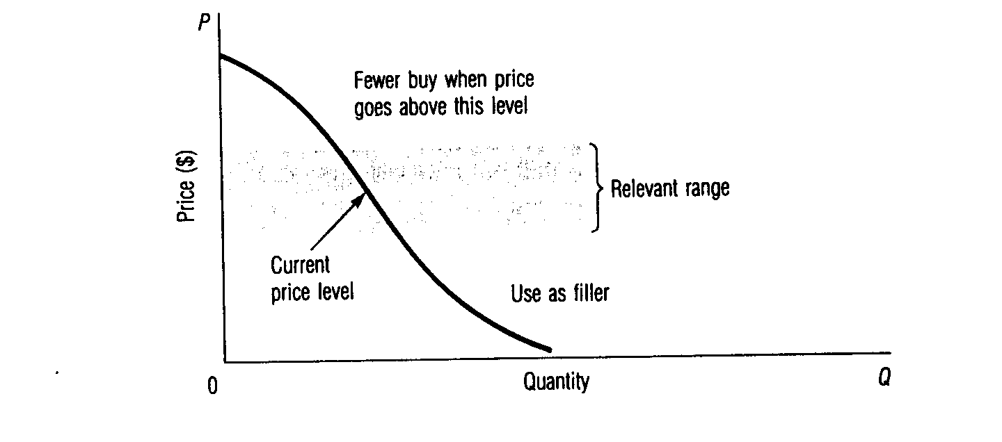

Supply curves reflect supplier thinking

Generally speaking, suppliers' costs affect the quantity of products they are wiling to offer in a market during any period. In other words, their costs affect their supply schedules and supply curves. While a demand curve shows the quantity of products customers will be willing to buy at various prices, a supply curve shows the quantity of products that will be supplied at various possible prices. Eventually, only one quantity will be offered and purchased. So a supply curve is really a hypothetical (what-if) description of what will be offered at various prices. It is, however, a very important curve. Together with a demand curve, it summarizes the attitudes and probable behaviour of buyers and sellers about a particular product in a particular market-that is, in a product-market.

Some supply curves are vertical

We usually assume that supply curves tend to slope upward-that is, suppliers will be willing to offer greater quantities at higher prices. If a product’s market price is very high, it seems only reasonable that producers will be anxious to produce more of the product-and even put workers on overtime or perhaps hire more workers to increase the quantity they can offer. Going further, it seems likely that producers of other products will switch their resources (farms, factories, labour, or retail facilities) to the product that is in great demand.
On the other hand, if a very low price is being offered for a particular product, iYs reasonable to expect that producers will switch to other products-thus reducing supply. A supply schedule (Exhibit A-8) and a supply curve (Exhibit A-9) for potatoes illustrate these ideas. This supply curve shows how many potatoes would be produced and offered for sale at each possible market price in a given month.
In the very short run (say, over a few hours, a day, or a week), a supplier may not be able to increase the supply at all. In this situation, we would see a vertical supply curve. This situation is often relevant in the market for fresh produce. Fresh strawberries, for example, continue to ripen, and a supplier wants to sell them quickly-preferably at a higher price-but in any case, he wants to sell them.
If the product is a service, it may not be easy to expand the supply in the short run. Additional barbers or medical doctors are not quickly trained and licensed, and they only have so much time to give each day. Further, the prospect of much

.
.
.
.
.

Exhibit A-8 Supply Schedule for Potatoes (10-pound bags)

Number of bags sellers
Possible market price will supply per month at
Point per 10-Ib. bag each possible market price
A $1.60 17,000,000
B 1.30 14,000,000
C 1.00 11,000,000
D 0.70 8,000,000
E 0.40 3,000,000

Note: This supply curve is for a month to emphasize that farmers might have some control over when they deliver their potatoes. There would be a different curve for each month.

Exhibit A-9 Supply Curve for Potatoes (10-pound bags)
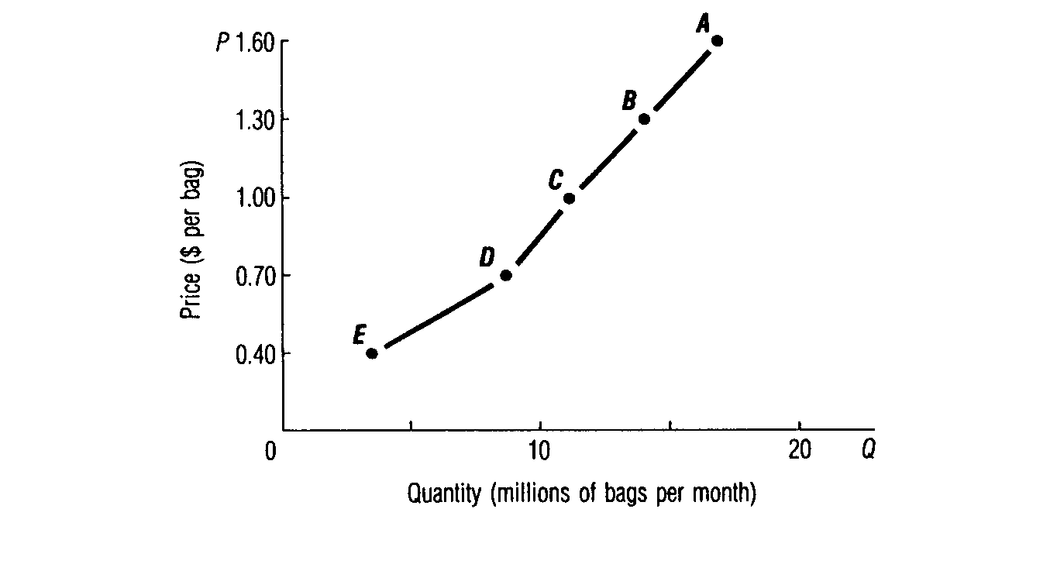

higher prices in the near future cannot easily expand the supply of many services. For example, a "hit” play or an "in" restaurant or nightclub is limited in the amount of "product" it can offer at a particular time.

Elasticity of supply

The term elasticity also is used to describe supply curves. An extremely steep or almost vertical supply curve-often found in the short run-is called inelastic supply because the quantity supplied does not stretch much (if at all) if the price is raised. A flatter curve is called elastic supply because the quantity supplied does stretch more if the price is raised. A slightly up-sloping supply curve is typical in longer-run market situations. Given more time, suppliers have a chance to adjust their offerings. And competitors may enter or leave the market.

DEMAND AND SUPPLY.INTERACT TO DETERMINE THE SIZE OF THE MARKET AND PRICE LEVEL

We have treated market demand and supply forces separately. Now we must bring them together to show their interaction. The intersection of these two forces determines the size of the market and the market price-at which point (price and quantity) the market is said to be in equilibrium.
The intersection of demand and supply is shown for the potato data discussed above. The demand curve for potatoes is now graphed against the supply curve in Exhibit A-9. See Exhibit A-10.
In this potato market, demand is inelastic-the total revenue of all the potato producers would be greater at higher prices. But the market price is at the equilibrium point-where the quantity and the price sellers are willing to offer are equal to the quantity and price that buyers are willing to accept. The $1.00 equilibrium price for potatoes yields a smaller total revenue to potato producers than a higher price would. This lower equilibrium price comes about because the many producers are willing to supply enough potatoes at the lower price. Demand is not the only determiner of price level. Cost also must be considered-via the supply curve.

Exhibit A-10 Equilibrium of Supply and Demand for Potatoes (10-pound bags)
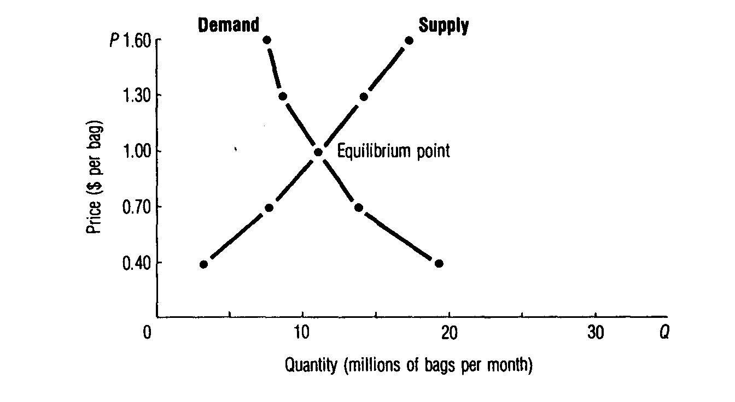

Some consumers get a surplus

It is important to note that not everyone gets only his money's worth in a sales transaction. Presumably, a sale takes place only if both buyer and seller feel they will be better off after the sale. But sometimes the price is better than "right.”
The price we are talking about is the market price set by demand and supply forces. Typically, demand curves are down-sloping, and some of the demand curve is above the equilibrium price. This is simply a graphic way of showing that some customers are willing to pay more than the equilibrium price if they have to. In effect, some of them are getting a "bargain" by being able to buy at the equilibrium price. Economists have traditionally called these bargains the consumer surplus-that is, the difference to consumers between the value of a purchase and the price they pay.
It is important to see that there is such a surplus because some business critics assume that consumers do badly in any business transaction. In fact, a sale takes place only if the consumer feels he is at least "getting his money's worth:' As we can see here, some are willing to pay much more than the market price.

DEMAND AND SUPPLY HELP US UNDERSTAND THE NATURE OF COMPETITION

The elasticity of demand and supply curves-and their interaction-help predict the nature of competition a marketing manager is likely to face. For example, an extremely inelastic demand curve means that the manager will have much choice in strategy planning-and especially price setting. Apparently customers like the product and see few substitutes. They are willing to pay higher prices before cutting back much on their purchases.
Clearly, the elasticity of a firm's demand curves makes a big difference in strategy planning, but there are other factors that affect the nature of competition. Among these are the number and size of competitors and the uniqueness of each firm's marketing mix. These ideas are discussed more fully in Chapters 3 and 4. Those discussions presume a real understanding of the contents of this appendix-so now you should be ready to handle them and later material involving demand and supply analysis (especially Chapters 18 and 19).

CONCLUSION

The economist's traditional demand and supply analysis provides useful tools for analysing the nature of demand and competition. It is especially important that you master the concepts of a demand curve and demand elasticity. How demand and supply interact helps determine the size of a market-and its price level. It also helps explain the nature of competition in different market situations. These ideas are discussed in Chapters 3 and 4 and then built on throughout the text. So careful study of this appendix will build a good foundation for later work.

Chapter3 - questions

1. Understand how to find marketing opportunities.
2. Know about the different kinds of marketing opportunities.
3. Know about defining generic markets and product-markets.
4. Know what market segmentation is.
5. Know three approaches to market-oriented strategy planning.
6. Know how to segment product-markets into sub markets.
7. Know dimensions that may be useful for segmenting markets.
8. Know a seven-step approach to market segmentation that you can do yourself.
9. Know what positioning is-and why it is useful.
10. Understand the important new terms (shown in bold).

Chapter 3

Finding attractive target markets is part of marketing strategy planning.

Motel 6 saw an opportunity. Most motels were pretty much alike-but some travellers were not satisfied with what they offered. These customers didn't want to pay extra for room service, a fancy restaurant, or someone to turn down their sheets at night. They just wanted a clean room, a good location, and a budget price for a one-night stay. Marketing managers for Motel 6 identified several groups of customers-vacation travellers in the 55-plus age bracket, salespeople who pay their own travel expenses, and young families-with similar "budget oriented" interests. Then they developed a marketing mix specifically targeted at these segments. They built less costly motels without showy lobbies, swimming pools, and restaurants. They located near highways and inexpensive eateries like McDonald's that appealed to their target customers. They used radio ads-rather than costly TV and print ads-to convey their message. They set the price low about half what most motels charged. This budget-oriented strategy was very profitable-and other motels began to copy it. To stay ahead, Motel 6 has made some changes-like adding free colour TVs and free local calls-while sticking with its basic strategy.'
Other motels and hotels are also targeting segments of the market with special needs. For example, Marriott’s Residence Inns target guests who want a nice place to stay for a week or more. Residence Inns feature fully equipped kitchens and grocery shopping services, fireplaces, and convenient recreation areas. The Ritz-Cariton in Atlanta caters to its Japanese guests by offering room information in their language, traditional slippers, green tea, and sake. The staff is even tutored in Japanese culture. The Hyatt Regency in Los Angeles attracts upscale business travellers with fancy conference rooms and a full library of general interest, business, and research books.

WHAT ARE ATTRACTIVE OPPORTUNITIES?

The main focus of this book is on marketing strategy planning-an important part of which is finding attractive target markets. But how do you identify a target market and decide if it offers good opportunities? Why would a company like Marriott that in the past had focused on motels seek to serve travellers in a new way by offering food preparation services to airlines?
In this chapter and the next chapter you will learn how to find possible market opportunities and choose the ones to be turned into strategies and plans. We will look first at how to identify attractive target markets. See Exhibit 3-1.
Possible opportunities are evaluated against screening criteria. We will be covering screening criteria in more detail in the next chapter. For now, however, you should see in Exhibit 3-1 that these criteria grow out of analysis of the company's resources, the long-run trends in the uncontrollable environments facing the firm, as well as the objectives of top management.
Attractive opportunities for a particular firm are those that the firm has some chance of doing something about-given its resources and objectives. Marketing strategy planning tries to match opportunities to the firm's resources-what it can do-and its objectives-what it wants to do.

Breakthrough opportunities are best

How many opportunities a firm "sees" depends on the thinking of top management-and the objectives of the firm. Some want to be innovators and eagerly search out new opportunities. Others are willing to be creative imitators of the leaders. And others are risk-avoiding "me-too" marketers.
Throughout this book, we will emphasize finding breakthrough opportunities--opportunities that help innovators develop hard-to-copy marketing strategies that will be very profitable for a long time. Finding breakthrough opportunities is important because imitators are always waiting to try to "share" the profits--if they can.

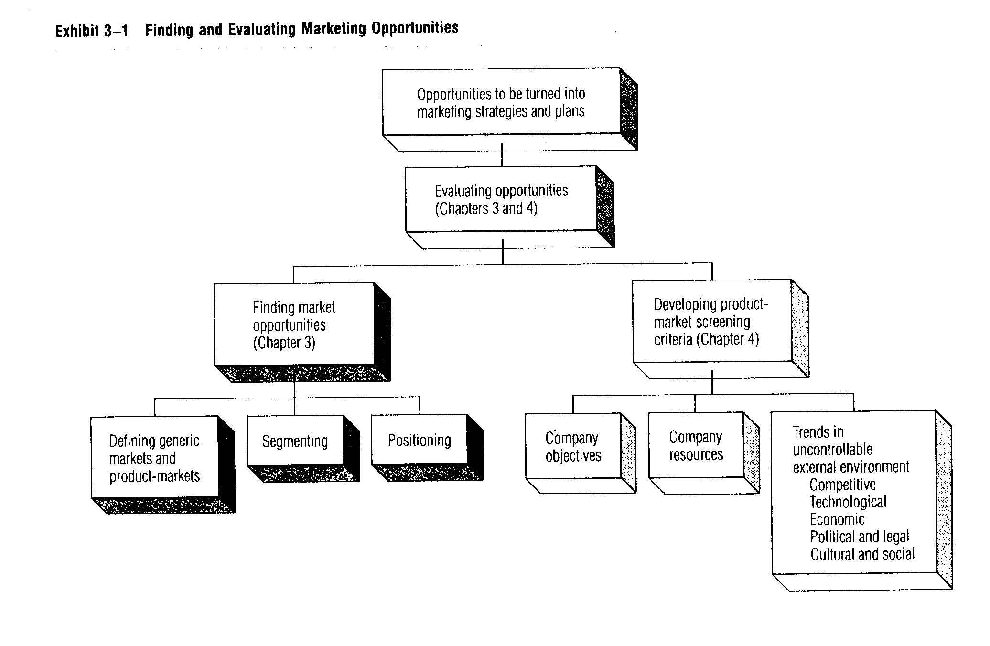

Competitive advantage is needed-at least

Even if a breakthrough opportunity isn’t possible, a firm should try to obtain a competitive advantage to increase its chances for profit or survival. Competitive advantage means that a firm has a marketing mix that the target market sees as better than a competitor’s mix.
The search for breakthrough opportunities and competitive advantage sometimes involves only “fine-tuning” a firm’s marketing mix(es). Sometimes it may require new facilities, new people, and totally new ways of solving problems. But it is vital to have some competitive advantages the promotion people have something unique to sell and success doesn’t hinge on offering lower and lower prices.3

TYPES OF OPPORTUNITIES TO PURSUE

Most people have unsatisfied needs-and alert marketers can find opportunities all around them. Starting with the firm's present product-markets is useful. By carefully defining its markets, the firm may see new opportunities. Or it may see opportunities beyond its present activities.
It helps to see the kinds of opportunities firms may find. Exhibit 3-2 shows the four broad possibilities: market penetration, market development, product development, and diversification. We will look at these separately, but some firms may pursue more than one type of opportunity at the same time.
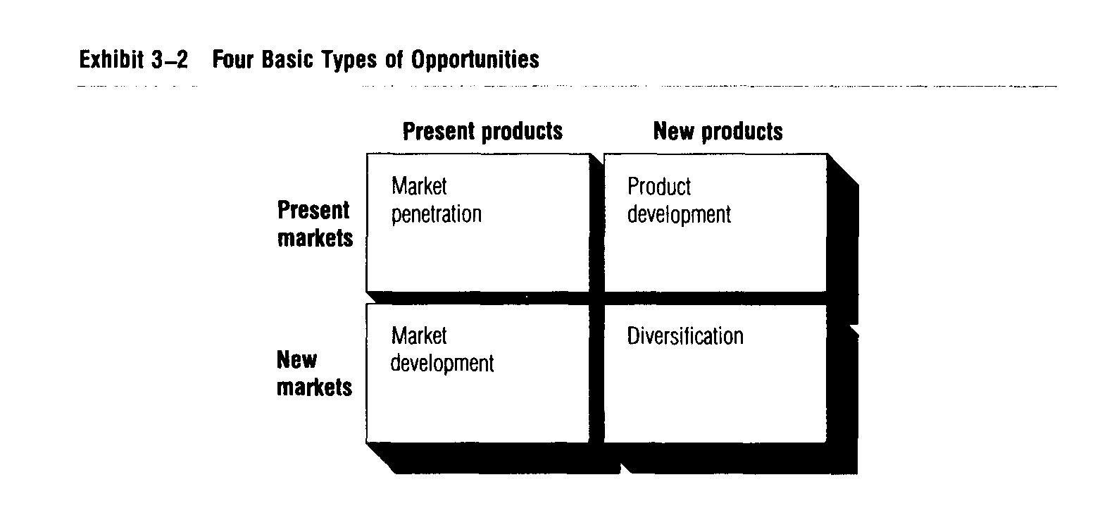

Market penetration

Market penetration is trying to increase sales of a firm’s present products in its present markets-probably through a more aggressive marketing mix. The firm may try to increase the customers’ rate of use or attract competitors’ customers or current nonusers. For example, Coca Cola has increased advertising to encourage people to take a morning Coke break instead of a coffee break and to switch from Pepsi to Diet Coke.
New promotion appeals alone may not be effective. A firm may need to add more stores in present areas for greater convenience. Short-term price cuts or coupon offers may help. AT&T has increased advertising and offered special discounts to encourage customers to choose AT&T over other long-distance telephone services.
Obviously, effective planning is aided by a real understanding of why some people are buying now and what will motivate them to shift brands, buy more, or begin or resume buying.

Market development

Market development is trying to increase sales by selling present products in new markets. This may only involve advertising in different media to reach new target customers. Or it may mean adding channels of distribution or new stores in new areas. For example, McDonald’s is reaching new customers by opening outlets in airports, office buildings, zoos, casinos, hospitals, and military bases. And it’s rapidly expanding into international markets with outlets in places like Brazil, Hong Kong, and Australia.
Market development may also involve a search for new uses for a product, as when Lipton provides recipes showing how to use its dry soup mixes to make party dip for potato chips.

Product development

Product development is offering new or improved products for present markets. Here, the firm should know the market’s needs; it may see ways of adding or modifying product features, creating several quality levels, or adding more types or sizes to better satisfy them. Computer software firms like Microsoft boost sales by introducing new versions of popular programs. Microsoft has also developed other types of new products for its customers. It now sells computer books and even computer hardware.

Diversification

Diversification is moving into totally different lines of business-which may include entirely unfamiliar products, markets, or even levels in the production marketing system. Until recently, Sony was strictly a producer of electronic equipment. With its purchase of CBS records, it has expanded into producing music-and it is considering other moves that will take it further yet from its traditional business.

Which opportunities come first?

Usually, attractive opportunities are fairly close to markets the firm already knows. It makes sénse to build on a firm’s strengths and avoid its weaknesses.
This may allow the firm to capitalize on changes in its present markets-or more basic changes in the uncontrollable environments.
Most firms think first of greater market penetration. They want to increase profits where they already have experience and strengths. But if they already have as big a share as they can get in their present markets, they may think of market development-finding new markets for their present products-including expanding regionally, nationally, or even internationally.
Marketers who have a good understanding of their present markets may see opportunities in product development-especially because they already have a way or reaching their present customers.
The most challenging opportunities involve diversification. Here, both new products and new markets are involved. The further the opportunity is from what the firm is already doing, the more attractive it may look to the optimists-and the harder it will be to evaluate. Opportunities that are far from a firm’s current experiences involve higher risks. The landscape is littered with failed efforts at diversification. For example, Holiday Corporation learned fast that making mattresses (like the ones used in its Holiday Inn motels) was not one of its strengths.4

SEARCH FOR OPPORTUNITIES CAN BEGIN BY UNDERSTANDING MARKETS

Breakthrough opportunities from understanding target markets

When marketing managers really understand their target markets, they may see breakthrough opportunities, as this Eastman Kodak example shows. Eastman Kodak-maker of cameras and photographic supplies-also produces an industrial
product, X-ray film. At first, Kodak felt all this market wanted was faster X-ray pictures at cheaper prices. But closer study showed that the real need in hospitals and health-care units was saving the radiologist’s time. Time was precious-but just giving the radiologist a faster picture wasn’t enough. Something more was needed to help do the whole job faster-and better.
Kodak came to see that its business was not just supplying X-ray pictures, but also helping to improve the health care supplied to patients. As a result, Kodak came up with new time-savers for radiologists: a handy cassette film pack and a special identification camera that records all vital patient data directly on X ray at the time the X ray is made. Before, such tagging had to be done during developing, which took more time and created the risk of error. This new marketing mix aimed at satisfying a different need. And it worked very well.

What is a company's market?

What is a company’s market is an important but sticky question. A market is a group of potential customers with similar needs and sellers offering various products-that is, ways of satisfying those needs.
Market-oriented managers develop marketing mixes for specific target markets. - This is very different from production-oriented managers-who just see a mass market of customers who are pretty much the same. Target marketers aim at specific “somebodies:’
Getting the firm to focus on specific target markets is vital. Target marketing requires a “narrowing down” process-to get beyond mass market thinking. But this narrowing down process is often misunderstood. Exhibit 3-3 shows the narrowing down process we will be talking about.

Don't just focus on the product

Some production-oriented managers ignore the tough part of defining markets. To make the narrowing down process easier, they just describe their markets in
terms of products they sell. For example, producers and retailers of greeting cards might define their market as the “greeting-card” market. But this production oriented approach ignores customers-and customers make a market! This also leads to missed opportunities. Hallmark isn’t missing these opportunities. Instead, Hallmark aims at the “personal-expression” market. It offers all kinds of products that can be sent as “memory makers”-to express one person’s feelings towards another. Hallmark has expanded far beyond Christmas and birthday cards-the major greeting card days-to jewellery, gift wrap, plaques, candles, and puzzles as well as to all-occasion and humorous cards.

From generic markets to product-markets

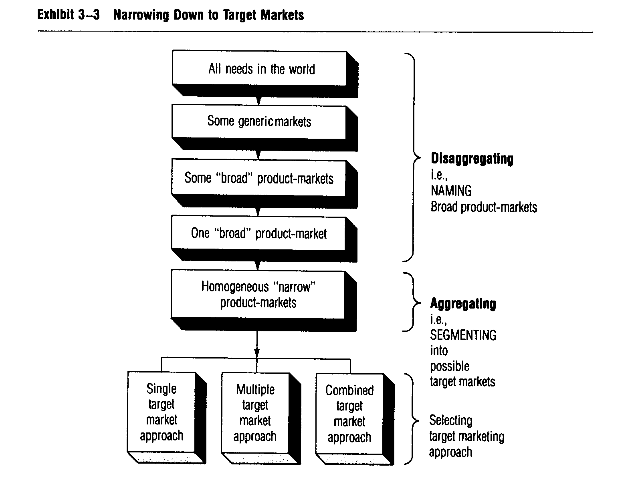
It’s useful to think of two basic types of market. A generic market is a market with broadly similar needs-and sellers offering various-often diverse-ways of satisfying those needs. In contrast, a product-market is a market with very similar needs and sellers offering various close substitute ways of satisfying those needs. A generic market description looks at markets broadly and from a customer’s viewpoint. Status-seekers, for example, have several very different ways to satisfy

status needs. A status-seeker might buy a new Mercedes, a Lindblad tour, or designer fashions from Neiman-Marcus. Any one of these very different products may satisfy this status need. Sellers in this generic status-seeker market have to focus on the need(s) the customers want satisfied-not on how one seller’s product (car, vacation, or designer label) is better than that of another producer.
It is sometimes hard to understand and define generic markets because quite different product types may compete with each other. But if customers see all these products as substitutes-as competitors in the same generic market-then marketers must deal with this complication.
Suppose, however, that one of our status-seekers decides to satisfy this status need with a new, expensive car. Then-in this product-market-Mercedes, Cadillac, and BMW may compete with each other for the status-seeker’s dollars. In this product-market concerned with cars and status (not just transportation!), consumers compare similar products to satisfy their status need.
Most companies quickly narrow their focus to product-markets because of the firm’s past experience, resources, or management preferences. And we will usually be thinking of product-markets when we refer to markets. But, when looking for opportunities, the broader generic market view should be considered.

Broaden market definitions to find opportunities

Broader market definitions-including generic market definitions and broader product-market definitions-can help firms find opportunities. But deciding how
broad to go isn’t easy. Too narrow a definition will limit a firm’s opportunities-but too broad a definiti0n will make the company’s efforts and resources seem insignificant.
Our strategy planning process helps in defining relevant markets. Here we are trying to match opportunities to a firm’s resources and objectives, so the relevant market for finding opportunities should be bigger than the firm’s present product market-but not so big that the firm couldn’t expand and be an important competitor. A small manufacturer of screwdrivers, for example, shouldn’t define its market
as broadly as “the worldwide tool users market’ or as narrowly as “our present screwdriver customers:’ But it may have the production and/or marketing potential to consider “the U.S. handyman’s hand-tool market:’ Careful naming of your product-market can help you see possible opportunities.

NAMING PRODUCT-MARKETS AND GENERIC MARKETS

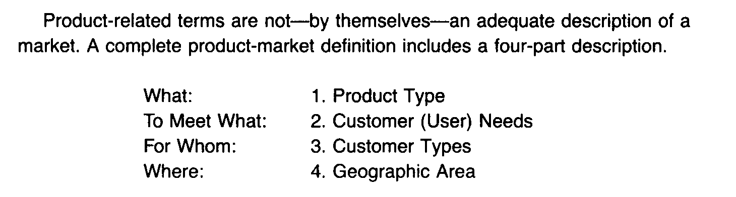
In other words, a product-market description must include customer-related terms-not just product-related terms. We will refer to these four-part descriptions as product-market “names” because most managers label their markets when they think, write, or talk about them. Such a four-part definition can be clumsy, however, so it’s often practical to use a “nickname”-as long as everyone understands the underlying four-part terms. And iYs desirable to have the nickname refer to people-not products-because, as we’ve emphasized, people make markets!

Product type should meet customer needs

Product type describes the goods and/or services the customers want. (Note: a particular product type may include no physical good. Many products are pure services.)
Customer (user) needs refer to the needs the product type will satisfy for the customer. At a very basic level, product types usually provide functional benefits such as nourishing, protecting, warming, cooling, transporting, cleaning, holding, drilling, assembling, and so forth. We should identify such “basic” needs first. But usually iYs necessary to go beyond these “basic” needs to emotional needs-such as needs for fun, excitement, pleasing appearance, or status. Correctly defining the need(s) relevant to a market is crucial and requires a good understanding of customers. These topics are discussed more fully in Chapters 7 and 8.
Both product type and customer need(s) should be defined together. Sometimes naming the product type reveals the needs at the same time. For example, floor wax products are for waxing. In other cases, naming the needs requires much thought because the same product type may satisfy several needs-or even several sets of needs. Cars, for example, can be for transporting and socializing and status and fun. When a single product may satisfy different needs, marketers have a basis for identifying two or more different product-markets.
Customer type refers to the final consumer or user of a product type. Here, we want to choose a name that describes all present (possible) types of customers. The emphasis in defining customer type should be on identifying the final consumer or user of the product type, rather than the buyer-if they are different. If the product type flows through middlemen on the way to final customers, marketers should avoid treating middlemen as a customer type-unless these middlemen actually use the product in their own business.
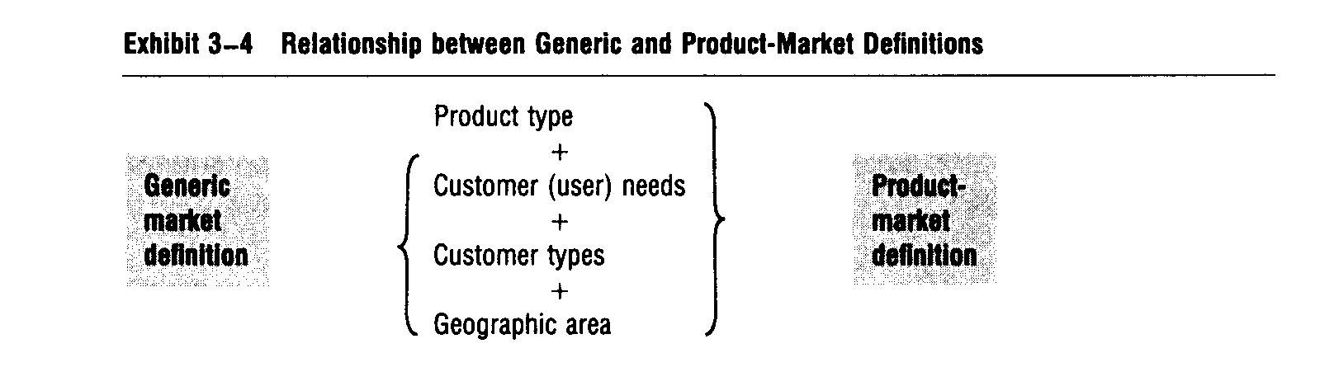
The geographic area is where a firm is competing-or thinking of competing for customers. While naming the geographic area may seem trivial, it should be taken seriously. Just understanding geographic boundaries of a market can suggest new opportunities. A supermarket in Los Angeles is not catering to all consumers in the Los Angeles area-so there may be opportunities for expansion to unsatisfied customers in that market. Similarly, if a firm is only aiming at the U.S. market, this may suggest world market opportunities.

No product type in generic market names

A generic market description doesn’t include any product-type terms. It consists of the last three parts of a product-market definition-omitting the product type.
This emphasizes that any product type that satisfies the needs of the customer can be a competitor in this generic market. Recall that in our “status-seeker” market example, very different product types were competitors. Exhibit 3-4 shows the relationship between generic market and product-market definitions.

Creativity is needed in naming markets

Creative analysis of the needs and attitudes of present and potential target markets -in relation to the benefits being offered by the firm and competitors-will help you see new opportunities. Later, we’ll study the many possible dimensions of markets. But for now you should see that defining markets only in terms of current products is not the best way to find new opportunities-or plan marketing strategies.

MARKET SEGMENTATION DEFINES POSSIBLE TARGET MARKETS

Market segmentation is a two-step process

Market segmentation is a two-step process of: (1) naming broad product- markets and (2) segmenting these broad product-markets in order~ to select target
markets and develop suitable marketing mixes.
This two-step process isn’t well understood. First-time market segmentation efforts often fail because beginners start with the whole “mass market” and try to find one or two demographic characteristics to segment this market. Customer behaviour is usually too complex to be explained in terms of just one or two demographic characteristics. For example, not all old men-or aIl young women-buy the same products or brands. Other dimensions usually must be considered starting with customer needs.

Naming broad product- markets is disaggregating

The first step in effective market segmentation is naming a broad product market of interest to the firm. This involves “breaking apart”-disaggregating-all
possible needs into some generic markets and broad product-markets in which the
firm may be able to operate profitably. See Exhibit 3-3. No one firm can satisfy everyone’s needs. So, the naming-disaggregating-step involves “brainstorming” about very different solutions to various generic needs and selecting some broad areas-broad product-markets-where the firm has some resources and experience. This means that a car manufacturer would probably ignore all the possible opportunities in food and clothing markets and focus on the generic market, “transporting people in the world;’ and probably on the broad product-market, “cars and trucks for transporting people in the world:’
Disaggregating is a practical, “rough-and-ready” approach that tries to “narrow down” the marketing focus to product-market areas where the firm is more likely to have a competitive advantage even to find breakthrough opportunities. It looks easy, but it actually requires a lot of thought and judgment about what the firm may be able to do for some consumers-and do better than some or all competitors so it will have a competitive advantage.

Market grid is m visual aid to market segmentation

Assuming that any market may consist of sub markets, it helps to picture a market as a rectangle with boxes representing smaller, more homogeneous product markets. See Exhibit 3-5.
Think of the whole rectangle as representing a generic market-or broad product-market. Now, think of the boxes as sub markets-product-markets. In the generic “transporting market’ discussed above, for example, we might see sub markets for bicycles, mopeds, motorcycles, airplanes, ships, buses, and “others:’

Segmenting is an aggregating process

Marketing-oriented managers think of segmenting as an aggregating process clustering together people with similar needs into a “market segment:’ A market-segment is a (relatively) homogeneous group of customers who will respond to a marketing mix in a similar way.
This part of the market segmentation process (see Exhibit 3-3) takes a different approach than the naming part. Here, we are looking for similarities rather than basic differences in needs. Segmenters start with the idea that each person is “one of a kind” but that it may be possible to aggregate some more or less homogeneous people into a product-market.
Segmenters see each of these one-of-a-kind people as having a unique set of dimensions. This is shown in Exhibit 3-6A. Here the many dots show each per

Exhibit 3-5 Market Grid Diagram with Sub markets (numbered)
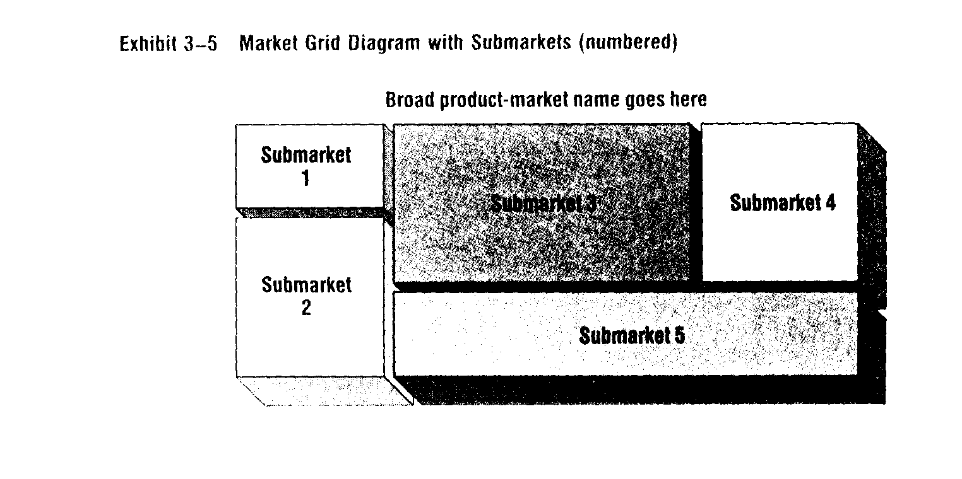
Submarket 3

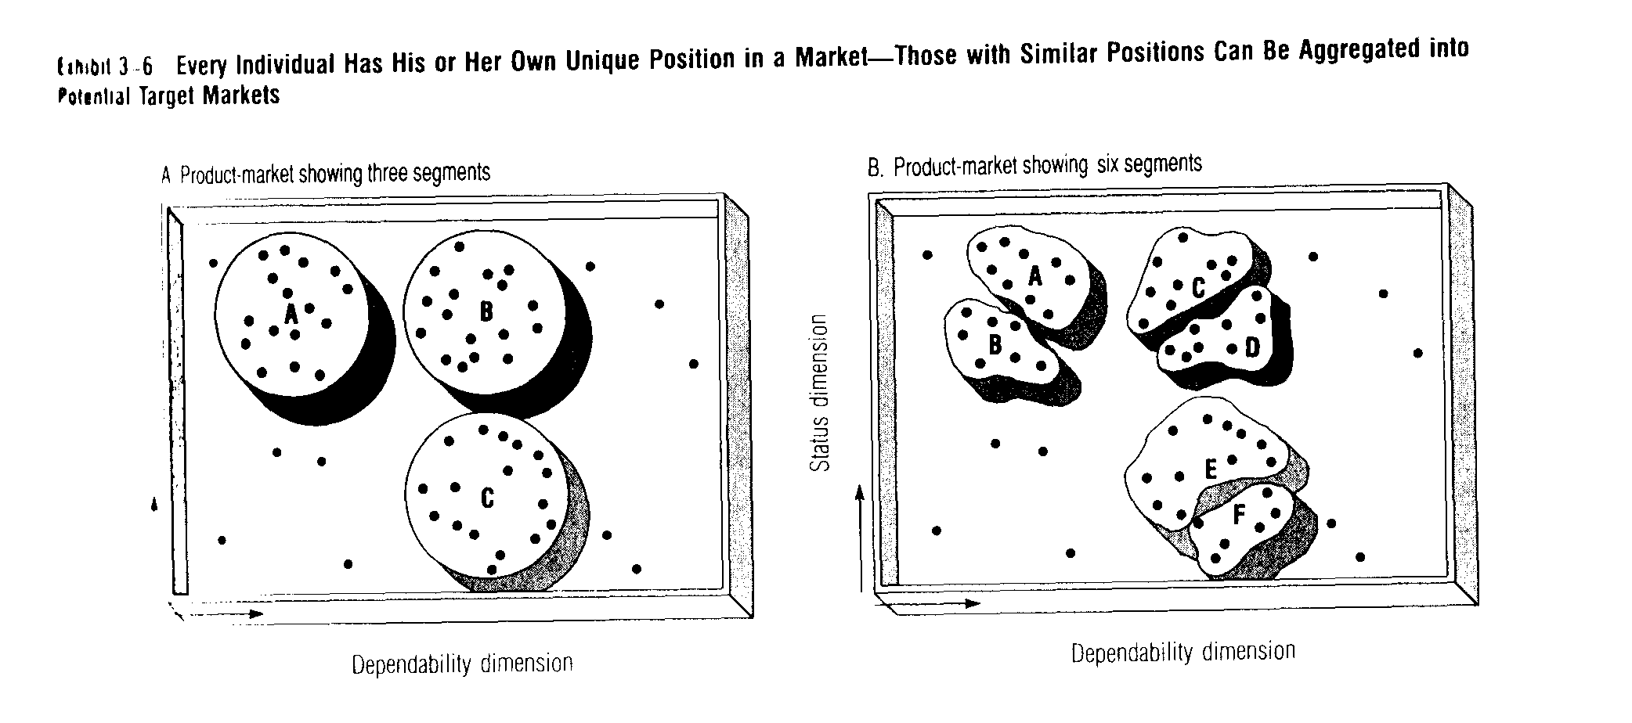
son's position in a product-market with two dimensions-need for status and need for dependability. While each person's position is unique, you can see that many of them are similar in terms of how much status and dependability they want. So a segmenter may aggregate these people into three (an arbitrary number) relatively homogeneous submarkets-A, B, and C. Group A might be called "Status Oriented" and Group C "Dependability Oriented:' Members of Group B want both and might be called the "Demanders:'

How far should the aggregating go?

The segmenter wants to aggregate individual customers into some workable number of relatively homogeneous target markets-and then treat each target market differently.
Look again at Exhibit 3-6A. Remember we talked about three segments. But this was an arbitrary number. As Exhibit 3-6B shows, there may really be six segments. What do you think-does this broad product-market consist of three segments or six segments?
Another difficulty with segmenting is that some potential customers just don't "fit' neatly into market segments. For example, not everyone in Exhibit 3-6B was put into one of the groups. Forcing them into one of the groups would have made these segments more heterogeneous-and harder to please. Further, forming additional segments for them probably wouldn't be profitable. They are too few and not very similar in terms of the two dimensions. These people are simply too "unique" to be catered to and may have to be ignored-unless they are willing to pay a high price for special treatment.
The number of segments that should be formed depends more on judgment than on some scientific rule. But the following guidelines can help.

Criteria for segmenting a broad product-market

Ideally, "good" market segments meet the following criteria (see Exhibit 3-7): 1. Homogeneous (similar) within the customers in a market segment should be
as similar as possible with respect to their likely responses to marketing mix variables and their segmenting dimensions.

Exhibit 3-7 Criteria for Segmenting
Substantial
Operational
Homogeneous within
Heterogeneous between

2. Heterogeneous (different) between - the customers in different segments should be as different as possible with respect to their likely responses to marketing mix variables and their segmenting dimensions.
3. Substantial - the segment should be big enough to be profitable.
4. Operational - the segmenting dimensions should be useful for identifying customers and deciding on marketing mix variables.

It is especially important that segments be operational. This means you should avoid dimensions that have no practical use. A personality trait such as moodiness, for example, might be found among the traits of heavy buyers of a product, but how could you use this fact? Personal salespeople would have to give a personality test to each buyer-an impossible task. Similarly, advertising media buyers or copywriters couldn't make much use of this information. So although moodiness might be related in some way to previous purchases, it would not be a useful dimension for segmenting.
The need for segments to be operational may lead marketers to include demographic dimensions such as age, income, location, and family size to help in planning marketing mixes. Information on these dimensions is readily available, and this can be very useful-at least for Place and Promotion planning. In fact, it is difficult to make some Place and Promotion decisions without such information.

Target marketers aim at specific targets

Once you accept the idea that broad product-markets may have submarkets, you can see that target marketers usually have a choice among many possible target markets.

There are three basic ways of developing market-oriented strategies in a broad product-market.

1. The single target market approach-segmenting the market and picking one of the homogeneous segments as the firm's target market.
2. The multiple target market approach-segmenting the market and choosing two or more segments, each of which will be treated as a separate target market needing a different marketing mix.
3. The combined target market approach - combining two or more submarkets into one larger target market as a basis for one strategy.
Note that all three approaches involve target marketing-they all aim at specific-and clearly defined-target markets. See Exhibit 3-8. For convenience, we'll call people who follow the first two approaches the "segmenters" and the people who use the third approach "combiners:'

Combiners try to satisfy pretty well

Combiners try to increase the size of their target markets by combining two or more segments-perhaps to gain some economies of scale, to reduce risk, or just because they don't have enough resources to develop more than one marketing mix. .
Combiners look at various submarkets for similarities rather than differences. Then they try to extend or modify their basic offering to appeal to these "combined" customers with just one marketing mix. See Exhibit 3-8. For example, combiners may try a new package, more service, a new brand, or new flavours. But even if they make product or other marketing mix changes, they are not trying to uniquely satisfy smaller submarkets. Instead, combiners try to improve the general appeal of their marketing mix to appeal to a bigger "combined" target market.

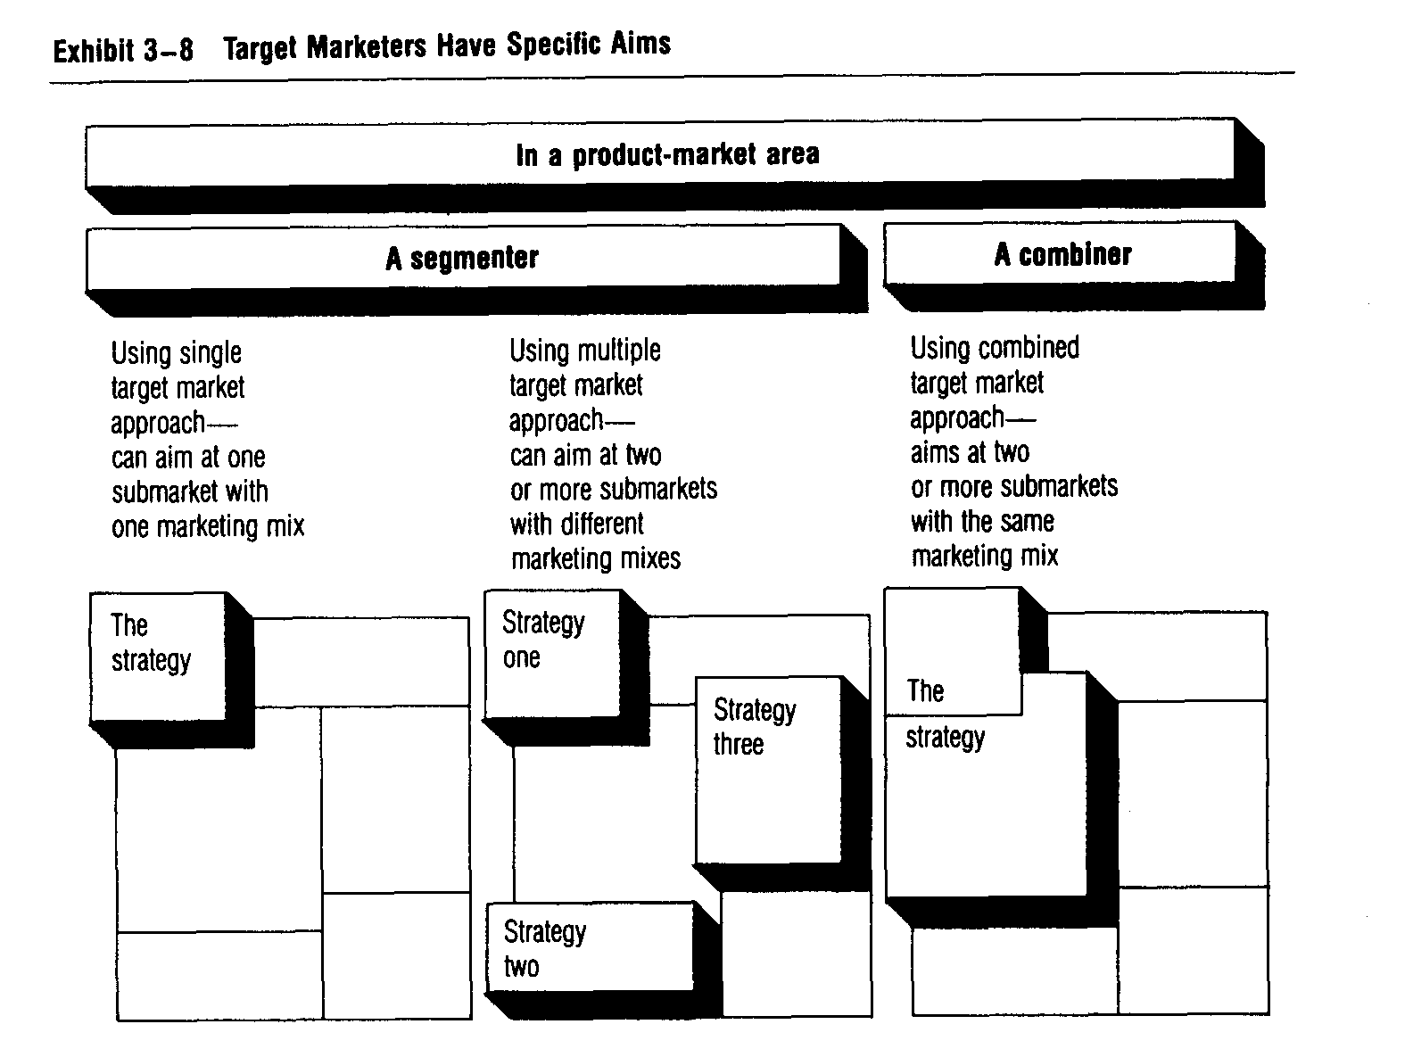

Segmenters try to satisfy "very well"

Segmenters, on the other hand, aim at one or more homogeneous segments and try to develop a different marketing mix for each segment. They want to satisfy each one very well.
Segmenters may make more basic changes in marketing mixes-perhaps in the product itself-because they are aiming at smaller target markets.
Instead of assuming that the whole market consists of a fairly similar set of customers (like the mass marketer does) or merging various submarkets together (like the combiner), a segmenter sees submarkets with their own demand curves-as shown in Exhibit 3-9. Segmenters believe that aiming at one-or some-of these smaller markets will provide greater satisfaction to the target customers and
greater profit potential for the firm.

Segmenting may produce bigger sales

Note that a segmenter is not settling for a smaller sales potential. Instead, by aiming at only a part of a larger product-market, the segmenter hopes to get a much larger share of his target market(s). In the process, total sales may be larger. The segmenter may even get a monopoly in "his" market(s).

Should you segment or combine?

Which approach should be used? This depends on the firm's resources, the nature of competition, and-most important-the similarity of customer needs, attitudes, and buying behaviour.
It is tempting to aim at larger combined markets instead of smaller segmented markets. If successful, such a strategy can result in economies of scale. Also, offering one marketing mix to two or more submarkets usually requires less investment-and may seem less risky-than offering different marketing mixes to different submarkets.

Too much aggregating is risky

Combiners must be careful not to aggregate too far. As they enlarge the target market, it becomes less homogeneous-and individual differences within each submarket may begin to outweigh the similarities. This makes it harder to develop marketing mixes that can do an effective job of reaching and satisfying potential customers within each of the submarkets.
A combiner faces the continual risk of innovative segmenters "chipping away" at the various segments of the combined target market-by offering more attractive marketing mixes to more homogeneous submarkets.'
In the extreme, a combiner may create a fairly attractive marketing mix but then watch segmenters capture one after another of its submarkets with more targeted marketing mixes-until finally the combiner is left with no customers at all!
In general, it's usually safer to be a segmenter-that is, to try to satisfy some customers very well instead of many just fairly well. That’s why many firms use the
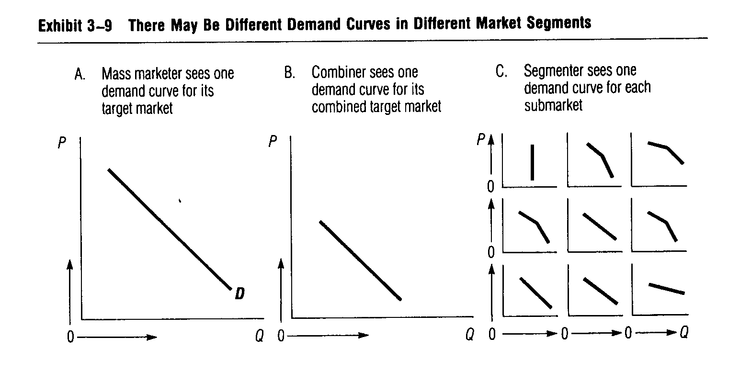
single or multiple target market approach instead of the combined target market approach. Procter & Gamble, for example, offers many products that seem to compete directly with each other (e.g., Tide versus Cheer or Crest versus Gleem). However, P&G offers "tailor-made" marketing mixes to each sub-market that is large enough-and profitable enough-to deserve a separate marketing mix. This approach can be extremely effective but may not be possible for a smaller firm with more limited resources. A smaller firm may have to use the single target market approach-aiming at the one sub-market niche where it sees the best opportunity.

Profit is the balancing point

Target marketers develop and implement whole strategies-they don't just segment markets. In practice, this means that cost considerations probably encourage more aggregating-to obtain economies of scale-while demand considerations suggest less aggregating-to satisfy needs more exactly.
Profit is the balancing point. It determines how unique a marketing mix the firm can afford to offer to a particular group.

WHAT DIMENSIONS ARE USED TO SEGMENT MARKETS?

Market segmentation forces a marketing manager to decide which product-market dimensions might be useful for planning marketing mixes. The dimensions should help guide marketing mix planning. Exhibit 3-10 shows the kinds of dimensions we'll be talking about in Chapters 6 through 8-and their probable effect on the four Ps. Ideally, we would like to describe any potential product-market in terms of all three types of customer-related dimensions-plus a product type description-because these dimensions will help us develop better marketing mixes.
Consumers have many dimensions. And several may be useful for segmenting a broad product-market.
Exhibit 3-11 shows some possible consumer market segmenting dimensions and their typical breakdowns. As Exhibit 3-11 shows, there are customer-related dimensions and situation-related dimensions-either of which may be more important in some cases.9
Exhibit 3-12 shows some possible dimensions for segmenting industrial markets and typical breakdowns.
With so many possible segmenting dimensions-and knowing that several dimensions may be needed to show what is really important in specific product-markets--how should we proceed?

What are the qualifying and determining dimensions?

To select the important segmenting dimensions, it is useful to think about two different types of dimensions. Qualifying dimensions are the dimensions that are relevant to including a customer type in a product-market. Determining dimensions are the dimensions that actually affect the customer’s purchase of a specific product or brand in a product-market. These are the segmenting dimensions we are seeking.

Exhibit 3-10 Relation of Potential Target Market Dimensions to Marketing Mix Decision Areas

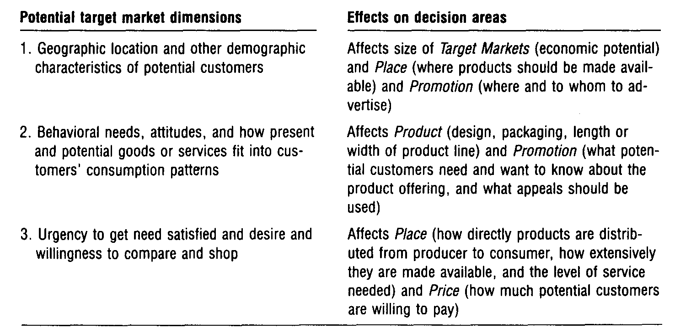

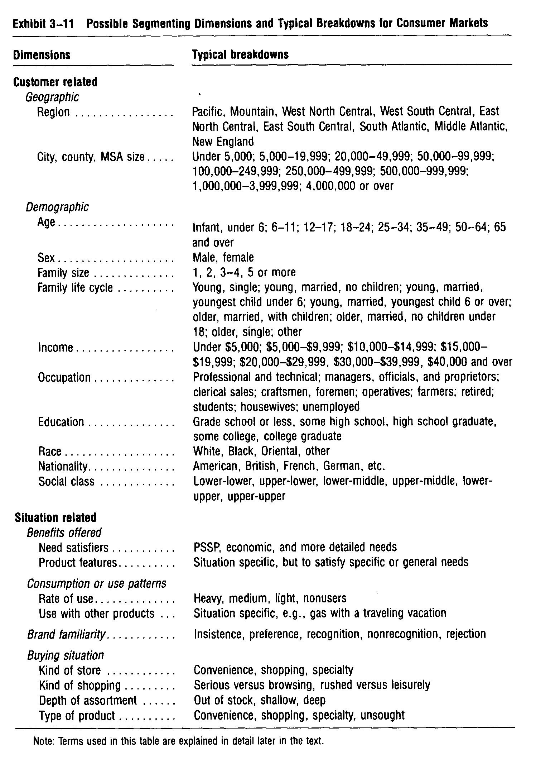
A prospective car buyer, for example, has to have enough money-or credit-to buy a car. He also must have--or be able to get-a driver's license. This still doesn't guarantee that he'll buy a ca~. He may just rent one, or continue borrowing his parents' o~ friends' cars, or hitchhike. He may not get around to actually buying a car until his status with his buddies is falling because he doesn't have "wheels:' This need may lead him to buy some car. But this dimension is not determining with respect to a specific brand or a specific model.

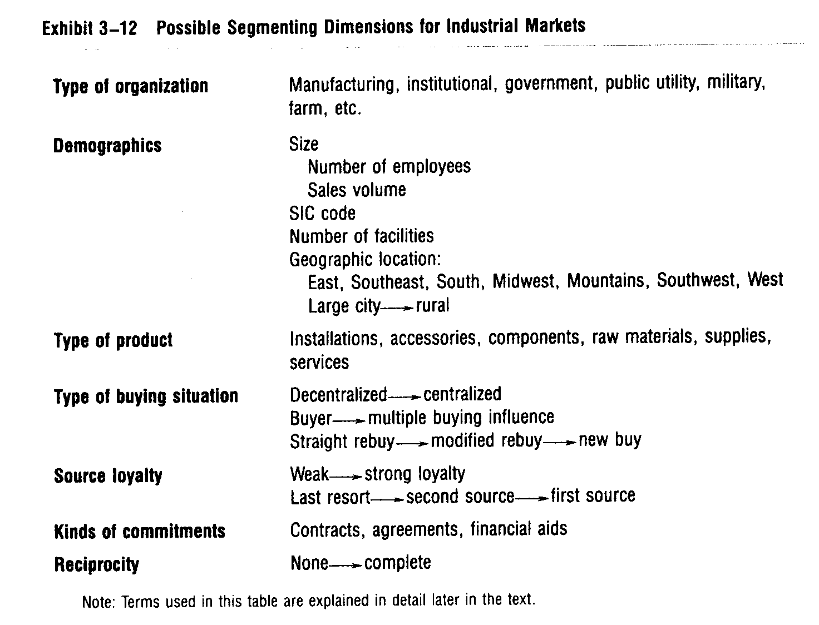

Determining dimensions may be very specific

How specific the determining dimensions are depends on whether you are concerned with a general product type or a specific brand. See Exhibit 3-13. The more specific you want to be, the more particular the determining dimensions may be. In a particular case, the determining dimensions may seem minor. But they are important because they are the determining dimensions. In the car status-seekers market, for example, paint colours or the brand name may determine which cars people buy.

Qualifying dimensions are important, too

The qualifying dimensions help identify the "core features" that must be offered to everyone in a product-market. Qualifying and determining dimensions work together in marketing strategy planning.
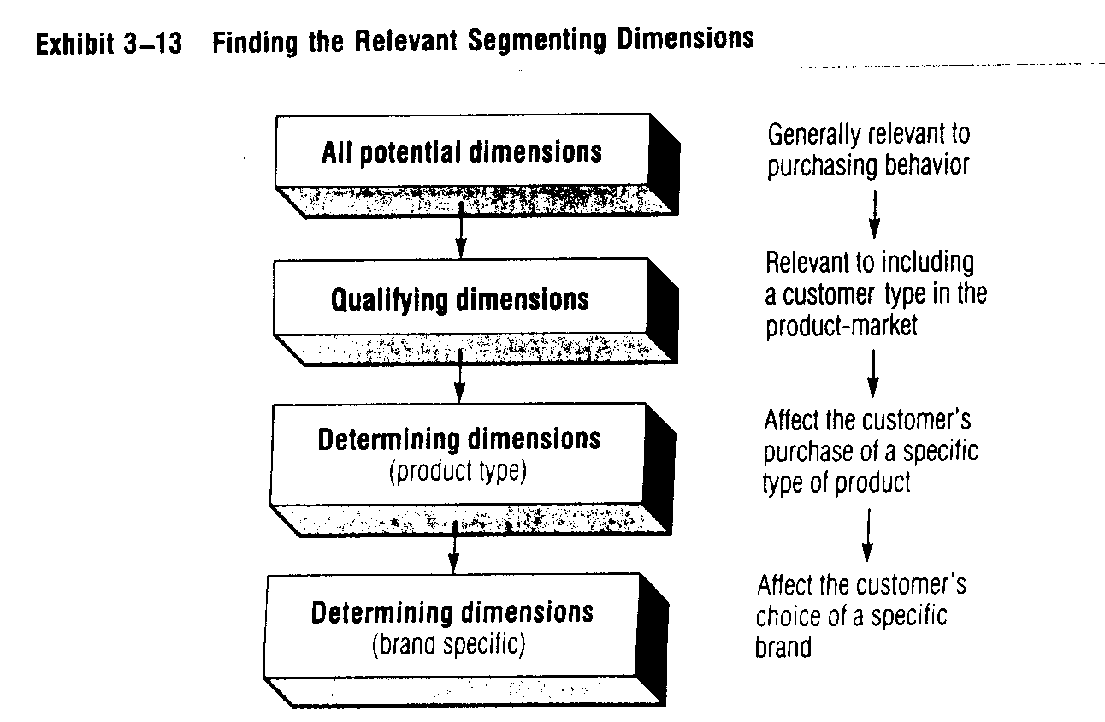

Different dimensions needed for different submarkets

Note that each different sub-market within a broad product-market may be motivated by a different set of dimensions. In the snack food market, for example, health food enthusiasts are interested in nutrition, dieters may care only about calories, and economical shoppers with lots of kids may want volume to "fill them up:' The related submarkets might be called: health-conscious snack food market, dieters' snack food market, and kids' snack food market. They would be in different boxes in a market grid diagram for the snack food market.

A SEVEN-STEP APPROACH TO SEGMENTING CONSUMER PRODUCT-MARKETS
Now let's go on to a logical, seven-step approach to market segmentation. Marketing research could help fine-tune some of the decisions made with this approach. But even without additional research this approach works-and has led to successful strategies. It is especially useful for finding the determining dimensions for product types. When you want to get down to dimensions for specific brands-especially when there are several competing brands-more sophisticated techniques may be needed.
To be sure you understand the approach, we will review each step separately, explain its importance, and use an ongoing example to show how each step works. The example is rental housing-in particular, the apartment market in a big urban area.
1: Name the broad product-market.
First, decide what broad product-market the firm wants to be in. This may be stated in the firm's objectives. Or if the firm is already in some product-market, its current position might be a good starting point. If it is just starting out, however, then many more choices are open-although the available resources, both human and financial, will limit the possibilities. It is better to build on the firm's strengths while avoiding its weaknesses-and competitors' strengths.
Example: A firm is building and renting small utility apartments for low-income families. A narrow view-considering only the products now being produced might lead the firm to think only of more low-income housing. A bigger view might see such apartments as only a small part of the total apartment market or total rental housing market-~r even the total housing market in the firm's geographic area. Taking an even bigger view, the firm could consider expanding to other geographic areas -or moving into other kinds of products-like office buildings or shopping centres).
There has to be some balance between naming the product-market too narrowly (same old product, same old market) and naming it too broadly (the whole world and all its needs). Here, the firm decided on the whole apartment renter's market in one city-because this is where the firm had some experience.
2: List potential customers' needs.
Write down as many relevant needs as you can-considering all of the potential customers in the broad product-market. This is a "brainstorming" step. The list doesn't have to be complete yet, but should provide enough input to really stimulate thinking in the next steps. Possible needs can be seen by thinking about why some people buy the present offerings in this broad product-market.
Example: In the apartment renter's market, it is fairly easy to list some possible
needs: basic shelter, parking, play space, safety and security, distinctiveness, economy, privacy, convenience (to something), enough living area, attractive interiors, and good supervision and maintenance to assure trouble-free and comfortable living.
3: Form "homogeneous" submarkets-i.e., "narrow" product-markets.
Assuming that some people will have different needs than others, form one sub-market around yourself (or some "typical" customer) and then aggregate similar people into this segment as long as they could be satisfied by the same marketing mix. Write the important need dimensions of these people in a column to help decide whether each new person should be included in the first segment. Also, note the people-related characteristics (including demographics) of the product-markets you are forming-so you can name them later.
For example, if the people in one market (column) are college students looking for a "party environment;' this will help you understand what they want and why-and will help you name the market (perhaps as "the partners").
People who are not "homogeneous"-who don't fit in the first segment-should be used to form a new sub-market. List their different need dimensions in another column. Continue this classifying until three or more submarkets emerge.
Obviously, some judgment is needed here. But you should have some ideas about how you behave-and you can see that others have different needs and attitudes. We all have different preferences, but experienced observers do tend to agree, at least roughly, on how and why people behave.
Example: A college student living off campus probably wants an apartment to provide basic shelter, parking, economy, convenience to school and work, and enough room somewhere to have parties. An older married couple, on the other hand, has quite different needs-perhaps for basic shelter and parking, but also for privacy and good supervision so that they don't have to put up with the music that might appeal to the partners.
4: Identify the determining dimensions.
Review the list of need dimensions for each possible segment (column) and identify the determining dimensions (perhaps putting parentheses around them). Although the qualifying dimensions are important-perhaps reflecting "core needs" that should be satisfied-they are not the determining dimensions we are seeking now.
Careful thinking about the needs and attitudes of the people in each possible segment will help identify which are the determining dimensions. They may not seem very different from market to market, but if they are determining to those people then they are determining!
Example: With our apartment renters, the need for basic shelter, parking, and safety and security are probably not determining. Everyone has these qualifying needs. Ignoring these common needs helps you see the determining dimensions such as the needs for privacy, club facilities, strong management, and so on.
See Exhibit 3-14.
5: Name (nickname) the possible product-markets.
Review the determining dimensions-market by market-and name (nickname) each one based on the relative importance of the determining dimensions (and aided by your description of the customer types). A market grid is a good way to help visualize this broad product-market and its narrow product-markets.
Draw the market grid as a rectangle with boxes inside representing smaller,

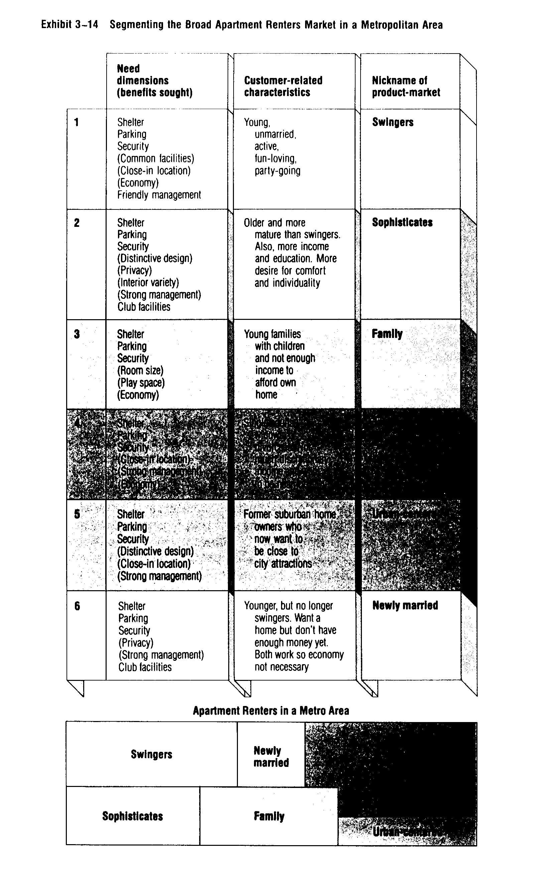
4

Shelter
Parking
Security
(Close-in location)
(Strong management)
(Economy)
Single adults, widows
or divorcees. Not much
discretionary income and want to be near job

Job-centered

Urban centered
Job-centered

Urban centered

more homogeneous segments. See Exhibit 3-14. Think of the whole rectangle as representing the broad product-market with its name on top. Now think of each of the boxes as narrow product-markets. Since the markets within a broad product-market usually require very different dimensions, don't try to use the same two dimensions to name the markets-or to label the sides of the market grid boxes. Rather, just think of the grid as showing the relative sizes of product-market segments. Then, label each segment with its nickname.
Example: We can identify the following apartment renter submarkets: swingers, sophisticates, family-oriented, job-centered, and urban-centered. See Exhibit 3-14. Note that each segment has a different set of determining dimensions (benefits sought) that follows directly from customer type and needs.
6. Evaluate why product-market segments behave as they do
After naming the markets as we did in Step 5, think about what else is known about each segment to help you understand how and why these markets behave the way they do. Different segments may have similar-but slightly different-needs. This may explain why some competitive offerings are more successful than others. It also can lead to splitting and renaming some segments.
Example: Newly married couples might have been treated as "swingers" in Step 5 because the "married" characteristic did not seem important. But with more thought, we see that while some newly married couples are still swingers at heart, others have begun to shift their focus to buying a home. For these newly marrieds, the apartment is a temporary place. Further, they are not like the sophisticates and probably should be treated as a separate market. The point here is that these market differences might only be discovered in Step 6. It is at this step that the "newly married" market would be named-and a related column created to describe the new segment.
7. Make a rough estimate of the size of each product market segment.
Remember, we are looking for profitable opportunities. So now we must try to tie our product-markets to demographic data-or other customer related characteristics-to make it easier to estimate the size of these markets. We aren't trying to estimate our likely sales yet. Now we only want to provide a basis for Later forecasting and marketing mix planning. The more we know about possible target markets, the easier those jobs will be.
Fortunately, much demographic data is available. And bringing in demographics adds a note of economic reality. Some possible product-markets may have almost no market potential. Without some hard facts, the risks of aiming at such markets are great.
To refine the market grid, redraw the inside boxes so that they give a better idea of the size of the various segments. This will help highlight the larger-and perhaps more attractive-opportunities.
Example: It's possible to tie the swingers to demographic data. Most of them are between 21 and 35. The U.S. Census Bureau publishes detailed age data by city. Given age data and an estimate of what percentage are swingers, it's easy to estimate the number of swingers in a metropolitan area.

Market dimensions suggest a good mix

Once we have followed all seven steps, we should at least be able to see the outlines of the kinds of marketing mixes that would appeal to the various markets. Let's take a look.
We know that swingers are active, young, unmarried, fun-loving, and party-going. The determining dimensions (benefits sought) in Exhibit 3-14 show what the swingers want in an apartment. (It's interesting to note what they do not want-strong management. Most college students will probably understand why!)
A Dallas-area apartment complex made a very successful appeal to local swingers by offering a swimming pool, a putting green, a nightclub with bands and other entertainment, poolside parties, receptions for new tenants, and so on. And to maintain the image, management insists that tenants who get married move out shortly-so that new swingers can move in.
As a result, apartment occupancy rates have been extremely high. At the same time, other builders often have difficulty filling their apartments-mostly because their units are just "little boxes" with few unique and appealing features.

SEVEN-STEP APPROACH APPLIES IN INDUSTRIAL MARKETS, TOO

A similar seven-step approach can be used for industrial markets, too. The major change is in the first step-selecting the broad product-market. The needs are different.
Industrial customers usually have basic functional needs. Their demands are derived from final consumer demands-so the industrial market is concerned with purchases that help produce finished products. The functions industrial buyers are concerned about include, but are not limited to: forming, bending, grading, digging, cutting, heating, cooling, conducting, transmitting, containing, filling, cleaning, analysing, sorting, training, and insuring.
Defining the relevant broad product-market using both geographic dimensions and basic functional needs usually ensures that the focus is broad enough-that is, not exclusively on the product now being supplied to present customers. But it also keeps the focus from vaguely expanding to "all the industrial needs in the world:'
It is better to focus on needs satisfied by products, not product characteristics themselves. New ways of satisfying the need may be found-and completely surprise and upset current producers-if the product-market is defined too narrowly. For example, desktop computers and printers now compete in what some producers thought was the "typewriter market:' And telephone calls and fax machines are replacing letters-further reducing the need for typing. Perhaps this broad product-market is concerned with "thought processing and transmitting:' Certainly, the "typewriter" view is too narrow. Market-oriented strategy planners try to avoid surprises that result from such tunnel vision.

MORE SOPHISTICATED TECHNIQUES MAY HELP IN SEGMENTING

The seven-step approach is inexpensive, logical, practical-and it works. But computer-aided methods can help, too. A detailed review of the possibilities is beyond the scope of this book. But a brief discussion of some approaches will give you a flavour of how computer-aided methods work.
It is better to focus on needs satisfied by products, not product characteristics themselves. New ways of satisfying the need may be found-and completely surprise and upset current producers-if the product-market is defined too narrowly. For example, desktop computers and printers now compete in what some producers thought was the "typewriter market:' And telephone calls and fax machines are replacing letters-further reducing the need for typing. Perhaps this broad product-market is concerned with "thought processing and transmitting:' Certainly, the "typewriter" view is too narrow. Market-oriented strategy planners try to avoid surprises that result from such tunnel vision.
After the first step in the seven-step approach, the other steps are similar to segmenting consumer markets. The main difference is that segmenting dimensions like those shown in Exhibit 3-12 and discussed in Chapter 8 are used.

Clustering usually requires a computer

Clustering techniques try to find similar patterns within sets of data. "Clustering" groups customers who are similar on their segmenting dimensions into homogeneous segments. Clustering approaches use computers to do what previously was done with much intuition and judgment.
The data to be clustered might include such dimensions as demographic characteristics, the importance of different needs, attitudes toward the product, and past buying behaviour. The computer searches all the data for homogeneous groups of people. When it finds them, marketers study the dimensions of the people in the groups to see why the computer clustered them together. If the results make some sense, they may suggest new, or at least better, marketing strategies."
A cluster analysis of the toothpaste market, for example, might show that some people buy toothpaste because it tastes good (the sensory segment), while others are concerned with the effect of clean teeth on their social image (the sociables). Others are worried about decay (the worriers), and some are just interested in the best value for their money (the economic men). See Exhibit 3-15. Each of these market segments calls for a different marketing mix-although some of the four Ps may be similar.
Finally, a marketing manager has to decide which one (or more) of these segments will be the firm's target market(s).
You can see that these techniques only aid the manager. Judgment is still needed to develop an original list of possible dimensions-and then to name the resulting clusters.
Positioning segments by product features

Another approach to segmenting-positioning-shows where customers locate proposed and/or present brands in a market. It requires some formal marketing research but may be helpful when competitive offerings are quite similar. The results are usually plotted on graphs to help show where the products are "positioned" in relation to competitors. Usually, the products' positions are related to two product features that are important to the target customers.
Assuming the picture is reasonably accurate, managers then decide whether they want to leave their product (and marketing mix) alone or reposition it. This may mean physical changes in the product or simply image changes based on promotion. For example, most beer drinkers can't pick out their "favourite" brand in a blind test-so physical changes might not be necessary (and might not even work) to reposition a beer brand.
The graphs for positioning decisions are obtained by asking product users to make judgments about different brands-including their "ideal" brand-and then using computer programs to summarize the ratings and plot the results. The details of positioning techniques-sometimes called "perceptual mapping"-are beyond the scope of this text. But Exhibit 3-16 shows the possibilities.
Exhibit 3-16 shows the "product space" for different brands of bar soap using two dimensions-the extent to which consumers think the soaps moisturize and deodorize their skin. For example, consumers see Dial as quite low on moisturizing but high on deodorizing. Lifebuoy and Dial are close together-implying that consumers think of them as similar on these characteristics. Dove is viewed as different and is further away on the graph. Remember that positioning maps are based on customers' perceptions-the actual characteristics of the products (as determined by a chemical test) might be different!
Exhibit 3-15 Toothpaste Market Segment Description

 | Segment name
 | The sensory segment | The sociables segment | The worriers segment | The independent segment
Principal benefit sought | Flavor,  product appearance | Brightness of teeth | Decay prevention | Price
Demographic strengths | Children | Teens, young people | Large families | Men
Special behavioral characteristics | Users of spearmint flavored toothpaste | Smokers | Heavy users | Heavy users
Brands disproportionately favored | Colgate, Stripe | Macleans, Plus White Ultra Brite | Crest | Brands on sale
Personality characteristics | High self-involvement | High sociability | High hypochondriasis | High autonomy
Life-style characteristics | Hedonistic | Active | Conservative | Value-oriented

The circles on Exhibit 3-16 show sets of consumers clustered near their "ideal" soap preferences. Groups of respondents with a similar ideal product are circled to show apparent customer concentrations. In this graph, the size of the circles suggests the size of the segments for the different ideals.
Ideal clusters 1 and 2 are the largest and are close to two popular brands-Dial and Safeguard. It appears that customers in cluster 1 want more moisturizing than they see in Dial and Lifebuoy. However, exactly what these brands should do about this isn't clear. Perhaps both of these brands should leave their physical products alone-but emphasize moisturizing more in their promotion to make a stronger appeal to those who want moisturizers.

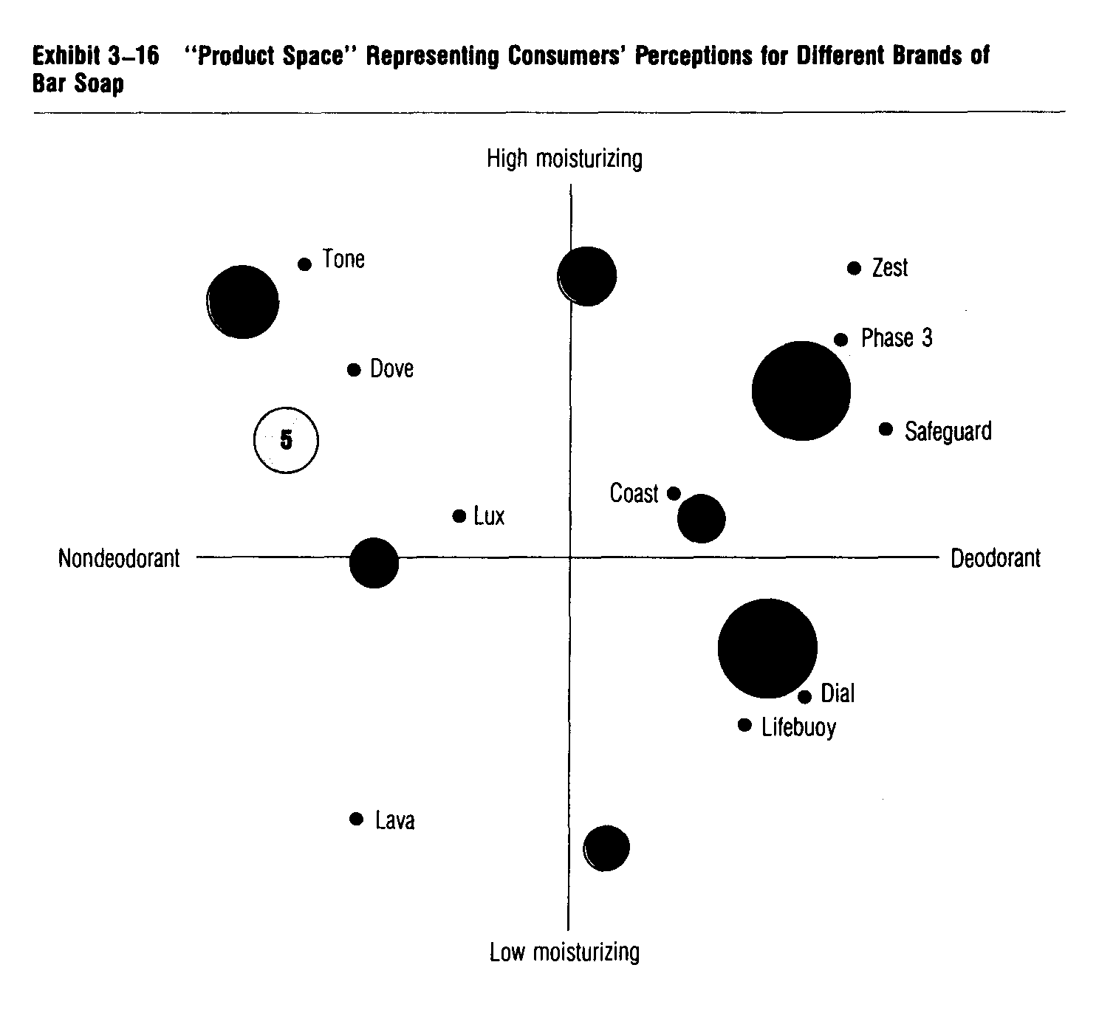

Lava doesn't seem to satisfy any of the ideal clusters very well. Therefore, some attempt probably should be made to reposition Lava-either through physical or image changes.
Note that ideal cluster 7 is not near any of the present brands. This may suggest an opportunity for introducing a new product-a strong moisturizer with some deodorizers. If some firm chooses to follow this approach, we would think of it as a segmenting effort.

Combining versus segmenting

Positioning analysis may lead a firm to combining-rather than segmenting-if managers think they can make several general appeals to different parts of a "combined" market. For example, by varying its promotion, Coast might try to appeal to clusters 8, 1, and 2 with one product. On the other hand, there may be clearly defined submarkets-and some parts of the market may be "owned" by one product or brand. In this case, segmenting efforts may be practical-moving the firm's own product into another segment of the general market area where competition is weaker.

Positioning as hart of broader analysis

The major value of positioning is to help managers understand how customers see their market. It is a visual aid to understanding a product-market. But positioning usually focuses on specific product features-that is, it is product-oriented. There is the risk that important customer-related dimensions-including needs and
attitudes-may be overlooked. But as part of a broader analysis of target markets, positioning can be very useful. The first time such an analysis is done, managers may be shocked to see how much customers' perceptions of a market differ from their own. For this reason alone, positioning is useful.
Premature emphasis on product features is dangerous, however. And it's easy to do if you start with a product-oriented definition of a market-as in the bar soap example. This leads to positioning bar soaps against bar soaps. But this can make a firm miss more basic shifts in markets. For example, bars might be losing popularity to liquid soaps. Or other products, like bath oils or bubble baths, may be part of the relevant competition. Such shifts would not be seen by only looking at alternative bar soap brands-the focus is just too narrow.
As we emphasize throughout the text, you must understand potential needs and attitudes when planning marketing strategies. If customers are treating quite different products as substitutes, then a firm has to position itself against those products, too. It must avoid focusing on physical product characteristics that are not the determining dimensions of the target market.

CONCLUSION

Creative strategy planning is needed for survival in our increasingly competitive markets. In this chapter, we discussed how to find attractive target market opportunities. We saw that carefully defining generic markets and product-markets can help find new opportunities. The shortcomings of a too narrow product-oriented view of markets were emphasized.
We also discussed market segmentation-the process of naming and then segmenting broad product-markets to find potentially attractive target markets. Some people try to segment markets by starting with the "mass market" and then dividing it into smaller submarkets based on a few dimensions. But this can lead to poor results. Instead, market segmentation should first focus on a broad product-market, and then group similar customers into homogeneous submarkets. The more similar the potential customers are, the larger the submarkets can be. Four criteria for evaluating possible product-market segments were presented.
Once a broad product-market has been segmented,
marketing managers can use one of three approaches to market-oriented strategy planning: (1) the single target market approach, (2) the multiple target market approach, and (3) the combined target market approach. In general, we encourage marketers to be segmenters rather than combiners.
We discussed a practical-"rough-and-ready" seven-step approach to market segmentation that works for both consumer and industrial markets. We also discussed some computer-aided segmenting approaches-clustering techniques and positioning.
In summary, good marketers should be experts on markets and likely segmenting dimensions. By creatively segmenting markets, they may spot opportunities-even breakthrough opportunities-and help their firms to succeed against aggressive competitors offering similar products. Segmenting is basic to target marketing. And the more you practice segmenting, the more meaningful market segments you will see.

Questions and Problems

1. Distinguish between an attractive opportunity and a breakthrough opportunity. Give an example.

2. Explain how new opportunities may be seen by defining a firm's markets more precisely. Illustrate for a situation where you feel there is an opportunity-namely, an unsatisfied market segment-even if it is not very large.

3. Distinguish between a generic market and a product-market. Illustrate your answer.

4. Explain the major differences among the four basic types of opportunities discussed in the text and cite examples for two of these types of opportunities.

5. Explain why a firm may want to pursue a market penetration opportunity before pursuing one involving product development or diversification.
6. Explain what market segmentation is.

7. List the types of potential segmenting dimensions and explain which you would try to apply first, second, and third in a particular situation. If the nature of the situation would affect your answer, explain how.

8. Explain why segmentation efforts based on attempts to divide the mass market using a few demographic dimensions may be very disappointing.

9. Illustrate the concept that segmenting is an aggregating process by referring to the admissions policies of your own college and a nearby college or university.

10. (a) Evaluate how "good" the seven submarkets identified in the market for apartments are (Exhibit 3-14) with respect to the four criteria for selecting good market segments. (b) Same as (a) but evaluate the four corner markets in the British home decorating market (Exhibit 2-9).

11. Review the types of segmenting dimensions listed in Exhibits 3-11 and 3-12, and select the ones you think should be combined to fully explain the market segment you personally would be in if you were planning to buy a new car today. List several dimensions and try to develop a shorthand name, like "swinger;' to describe your own personal market segment. Then try to estimate what proportion of the total car market would be accounted for by your market segment. Next, explain if there are any offerings that come close to meeting the needs of your market. If not, what sort of a marketing mix is needed? Would it be economically attractive for anyone to try to satisfy your market segment? Why or why not?

12. Identify the determining dimension or dimensions that explain why you bought the specific brand you did in your most recent purchase of a (a) soft drink, (b) shampoo, (c) shirt or blouse, and (a~ larger, more expensive item, such as a bicycle, camera, boat, and so on. Try to express the determining dimensions) in terms of your own personal characteristics rather than the product's characteristics. Estimate what share of the market would probably be motivated by the same determining dimension(s).

13. Apply the seven-step approach to segmenting consumer markets to the college-age market for off-campus recreation, which can include eating and drinking. Then evaluate how well the needs in these market segments are being met in your geographic area. Is there an obvious breakthrough opportunity waiting for someone?

14. Explain how the first step in the seven-step approach to segmenting markets would have to be changed to apply it in industrial markets. Illustrate your answer.

15. Explain how positioning can help a marketing manager identify target market opportunities.

